REPORT WIND ENGINEERING

PROJECT ON TRUCKS

GROUP J

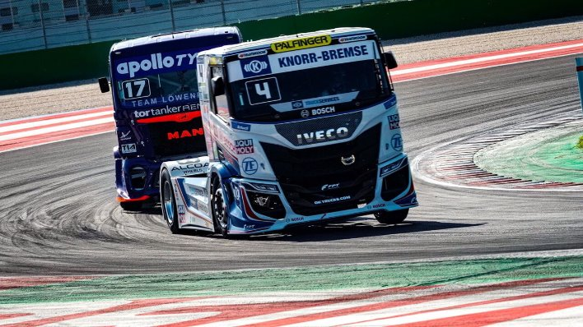

**Arnaboldi Eugenio** 10714991

**Beltramello** **Andrea** 10768271

**Ciriaco Marta** 10778514

**Danesi Silvia** 10730332

# Wind and metereological conditions

We first analyze the truck behaviour in different metereological conditions: dry, wet and snow. The reaction forces on wheels will change according to Pacejka model. Analyses are done for differnt wind conditions.

### Wind history 1

Dry, Wet and snow conditions are compared using *Wind history 1*: we notice a very similar behaviour for the loads on wheels and for the trajectory in cases dry and wet, while in snow condition we have a larger displacement in y direction and smoother curves for both the loads and the trajectory. However, the wind is not strong enough to cause a rollover of the truck.

Dry condition

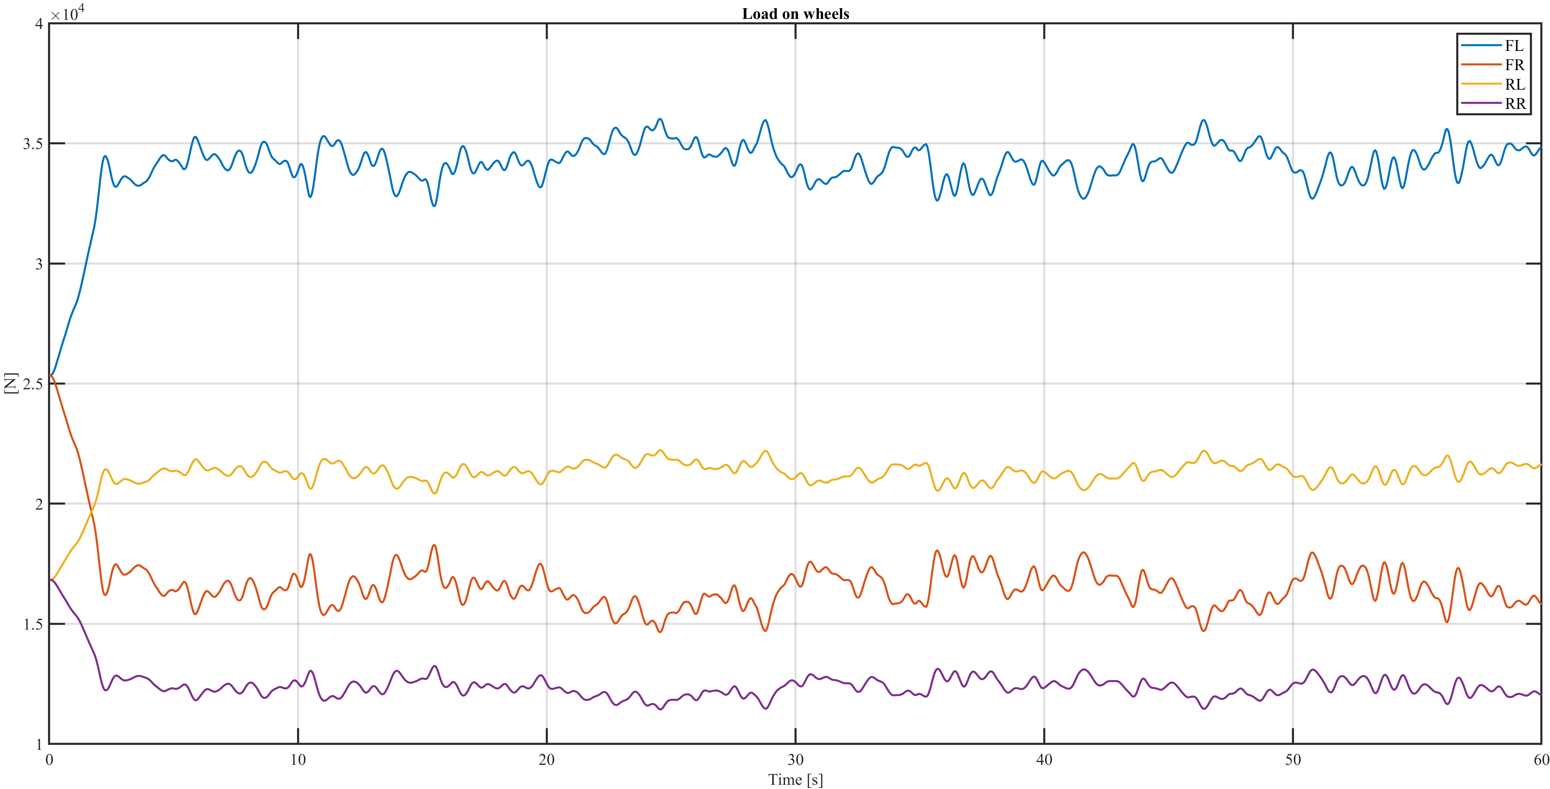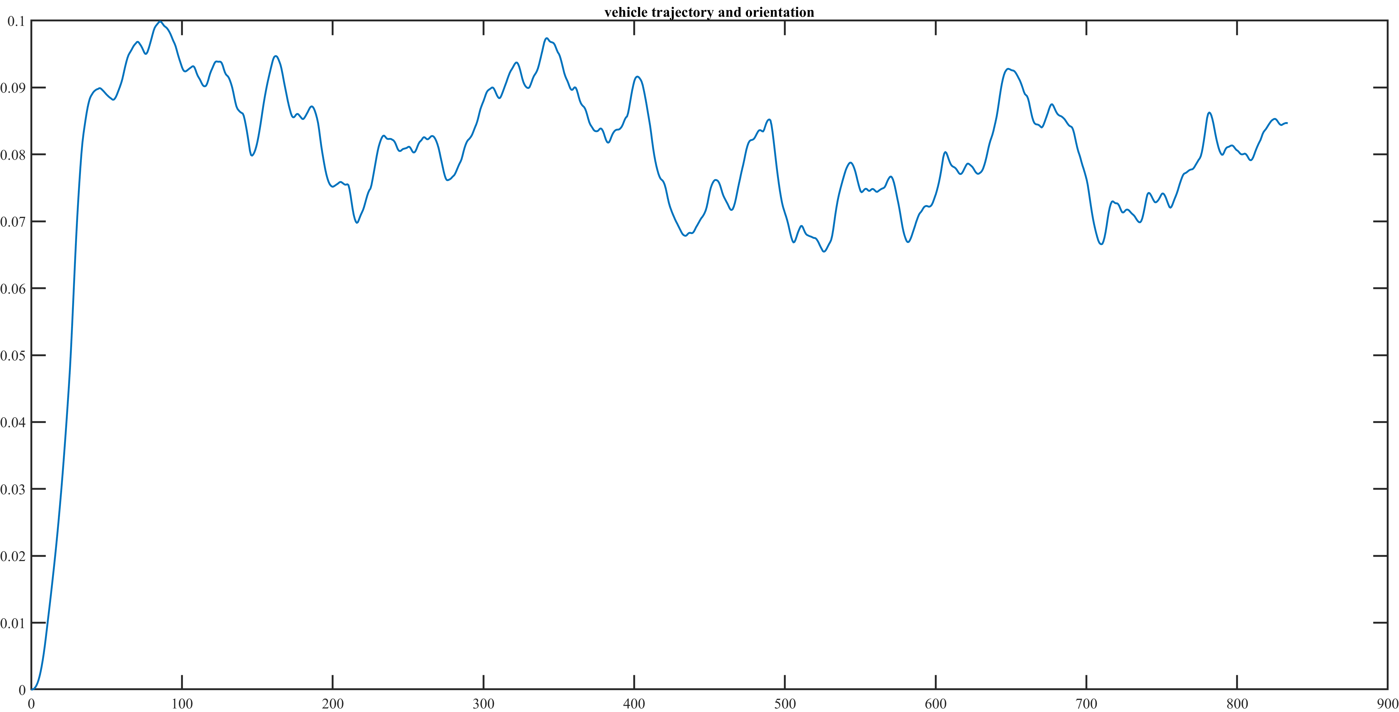

Wet condition

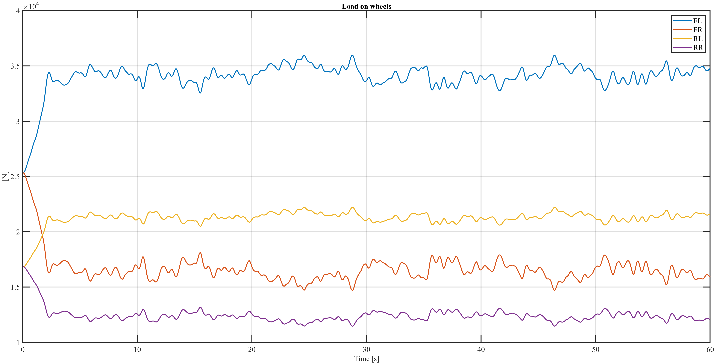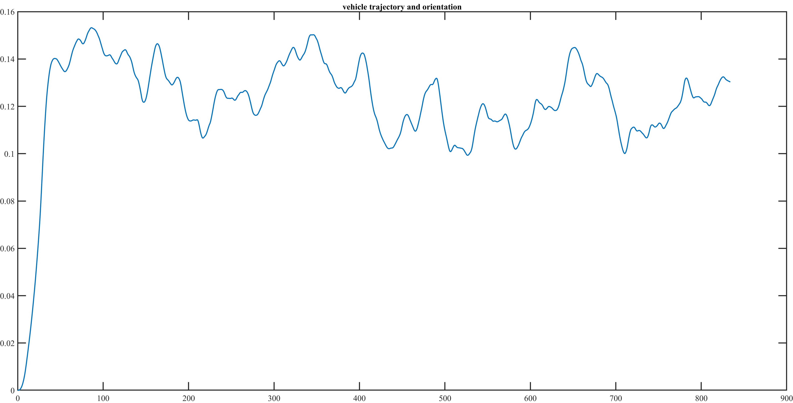

Snow condition

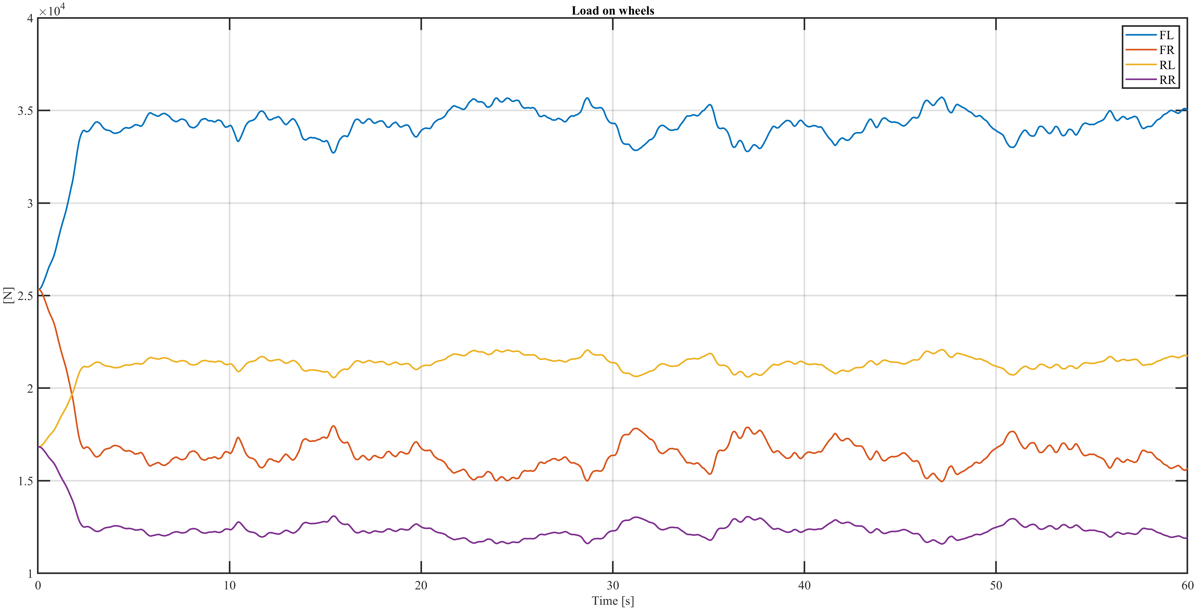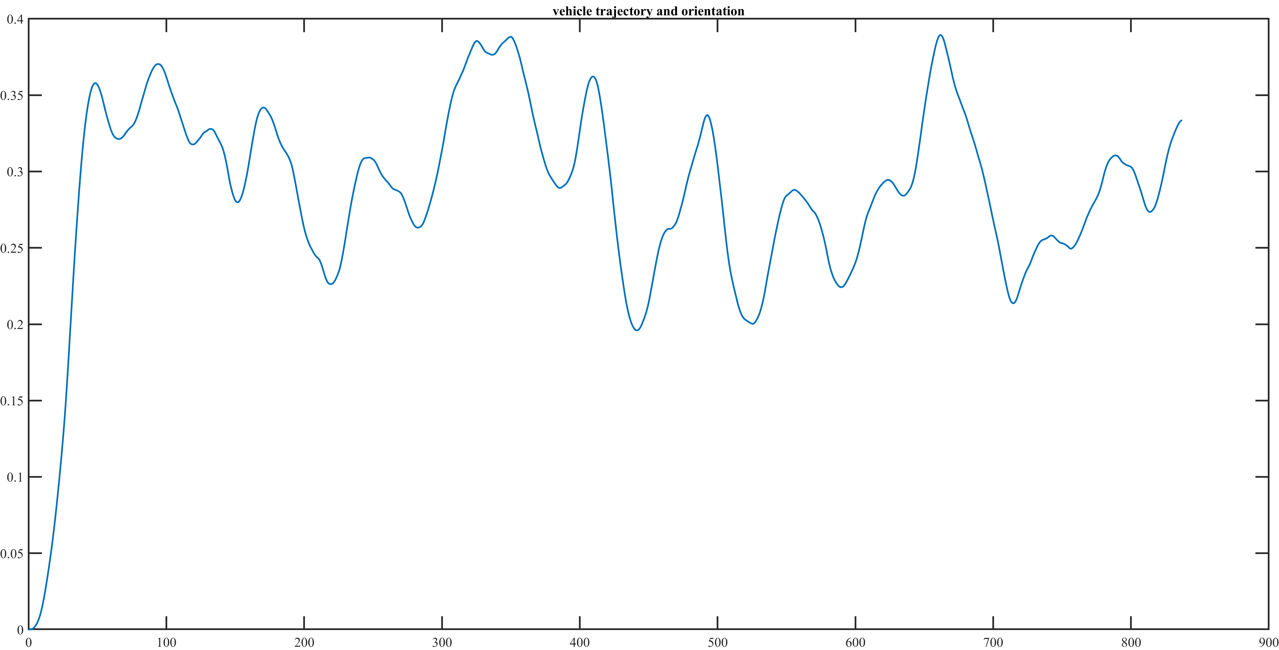

### Turbulence influence: comparison between wind history 4 and 6

Here we analize the influence of turbulence in the wind: for both wind histories 4 and 6 in dry conditions we have a velocity of the wind equal to 30 m/s, but a turbulence intensity of 0.7% for *wind history 4* and of 25% for *wind history 6.* It can be noticed in the following figures that we have a much more limited behaviour for *wind history 4,* while for *wind history 6* we have higher peaks. This is due to the wider frequency bandwidth.

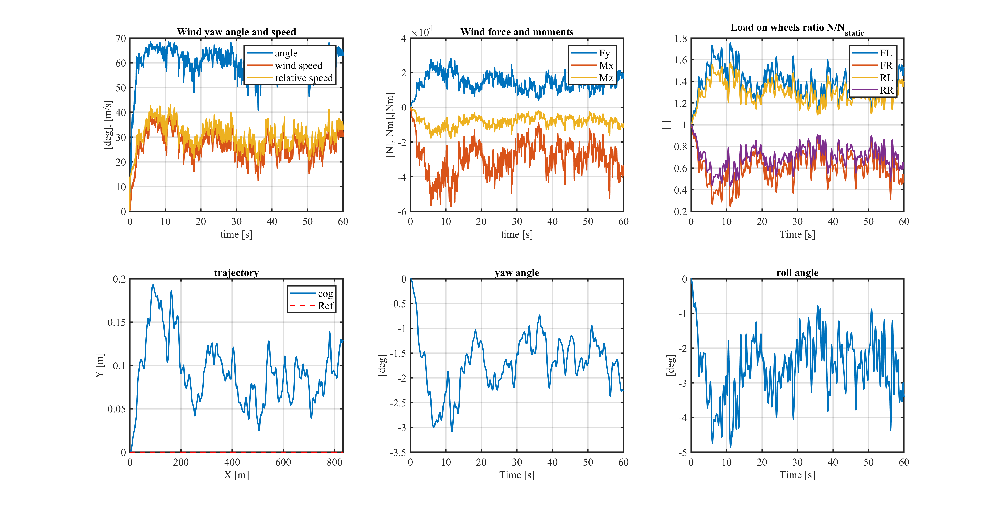

Wind history 4

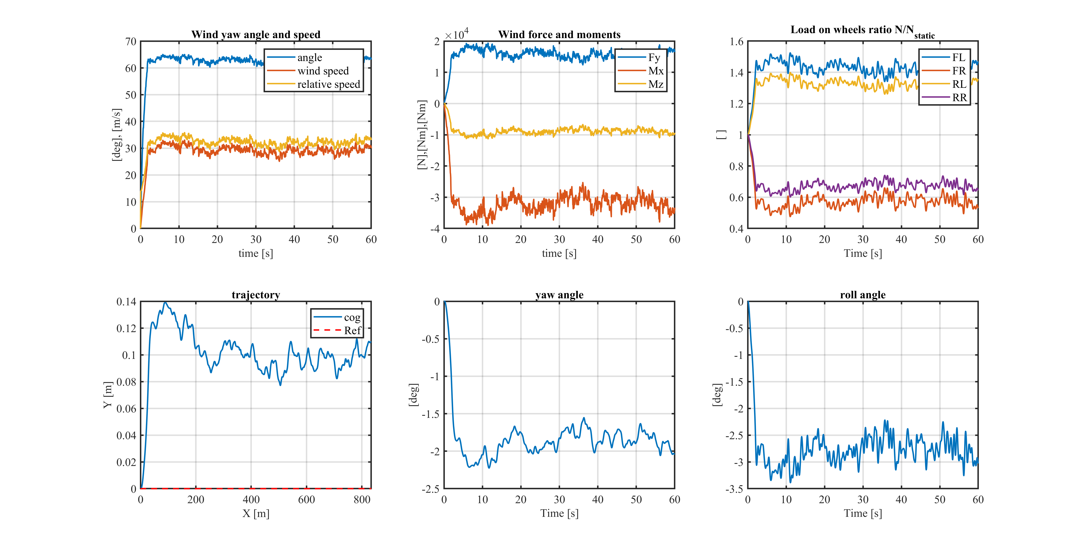Wind history 6

# Load on truck

### Lambda = 0.25, Dry conditions

The truck is loaded just a quarter of its maximum capacity, therefore it is more influenced by wind action. Roll over happens at about 5 seconds.

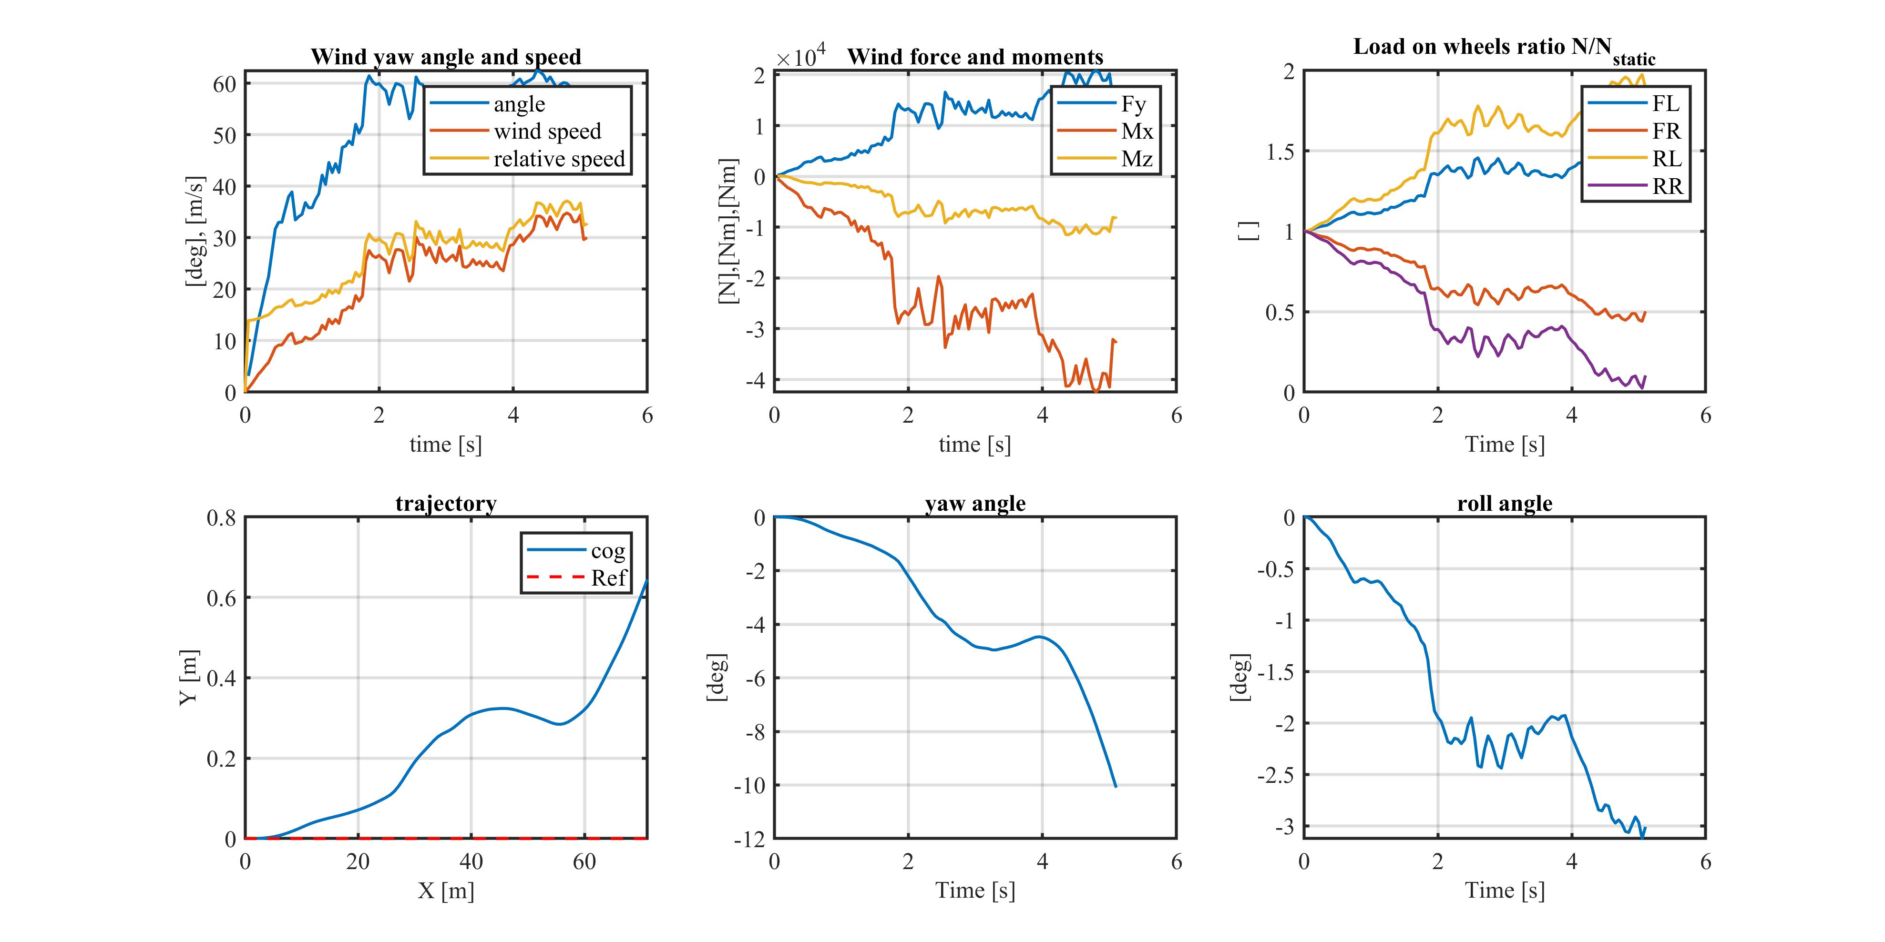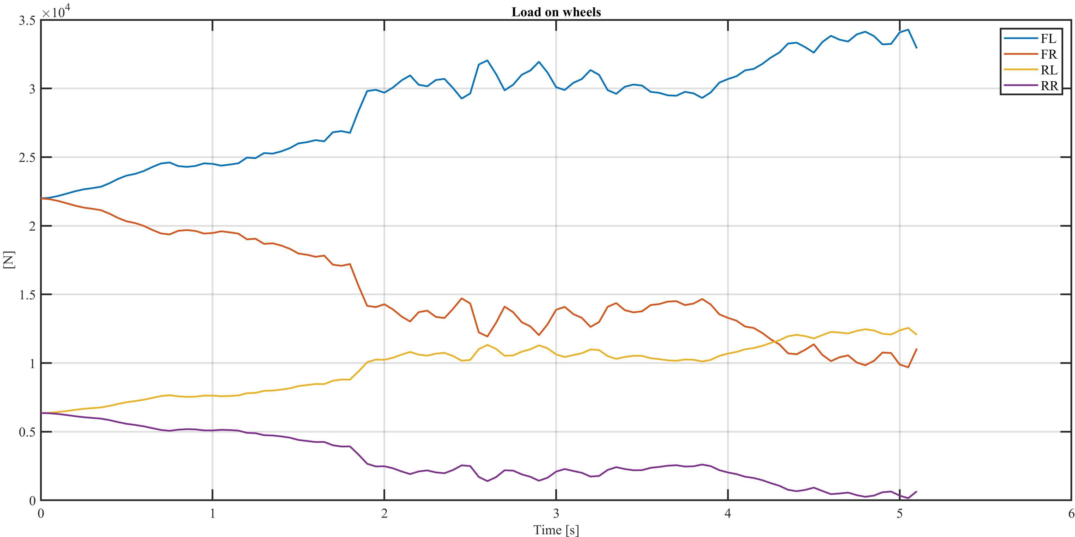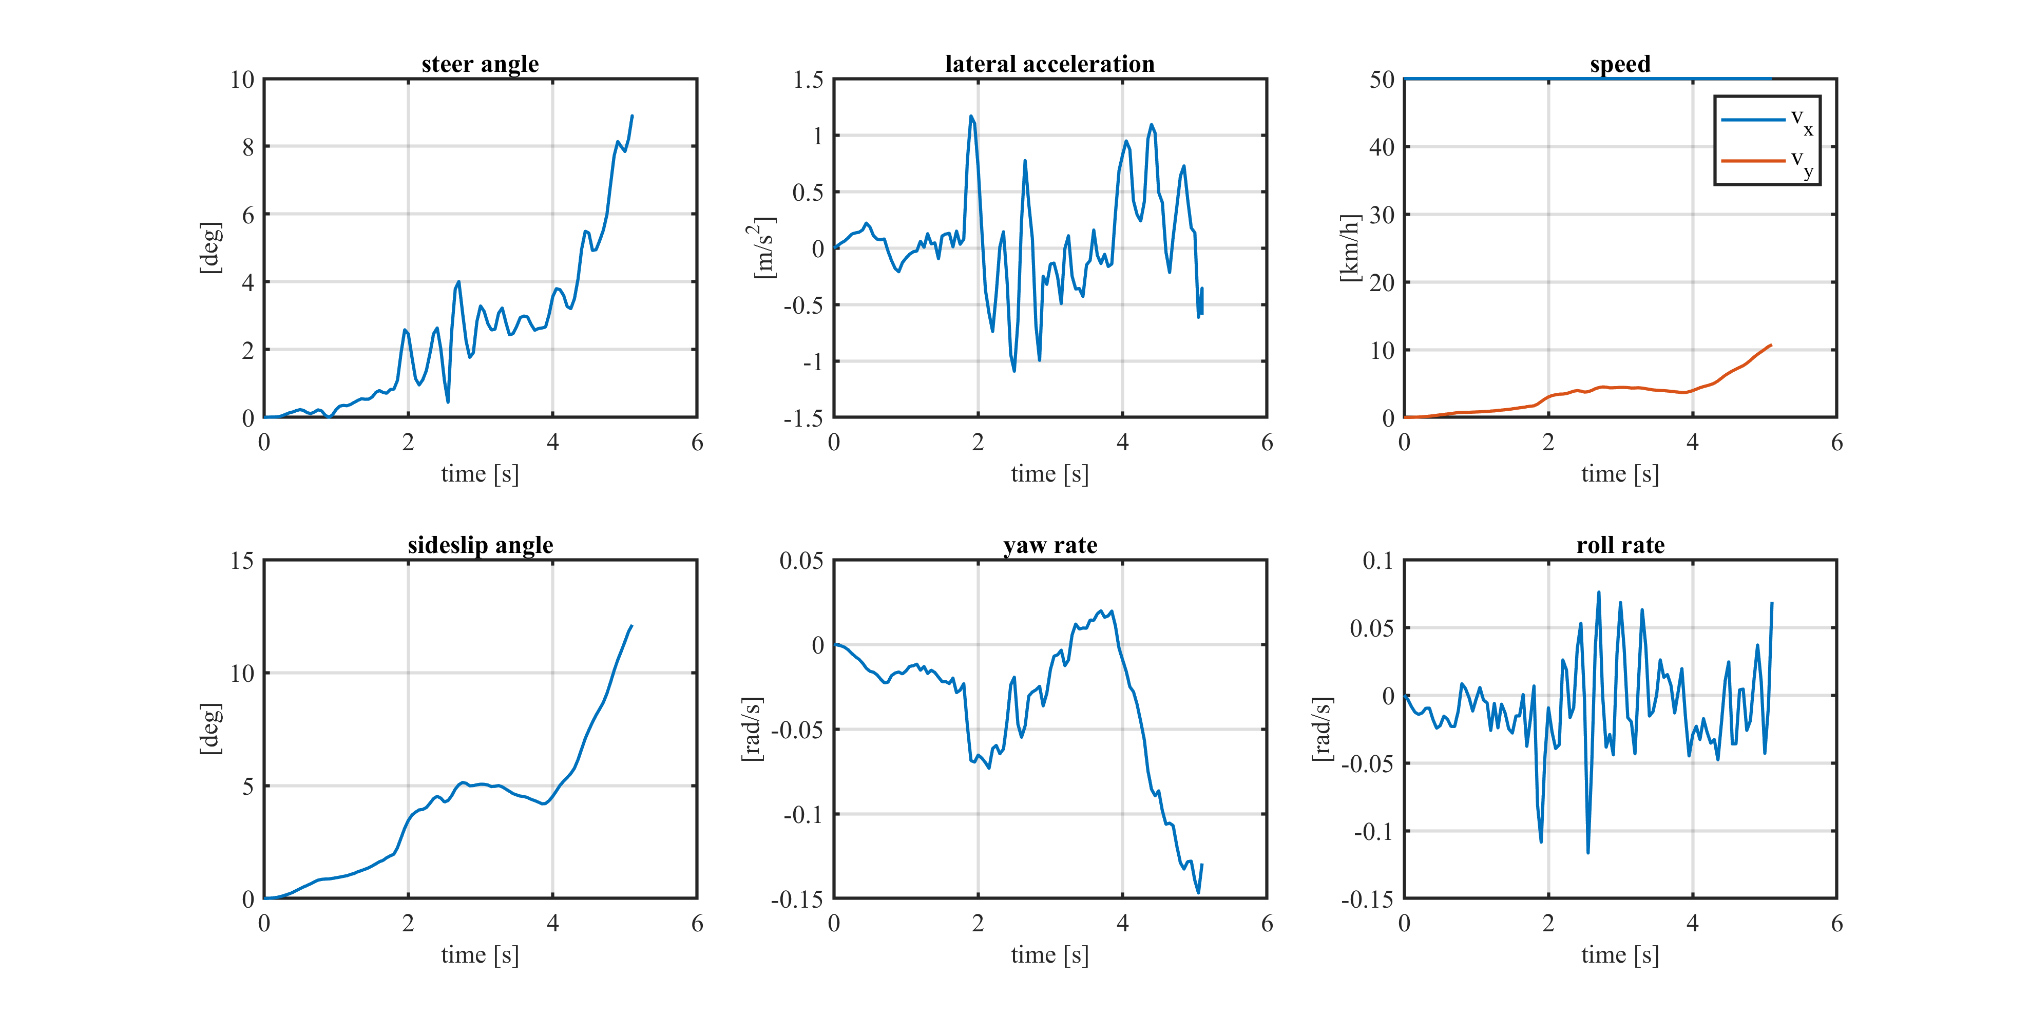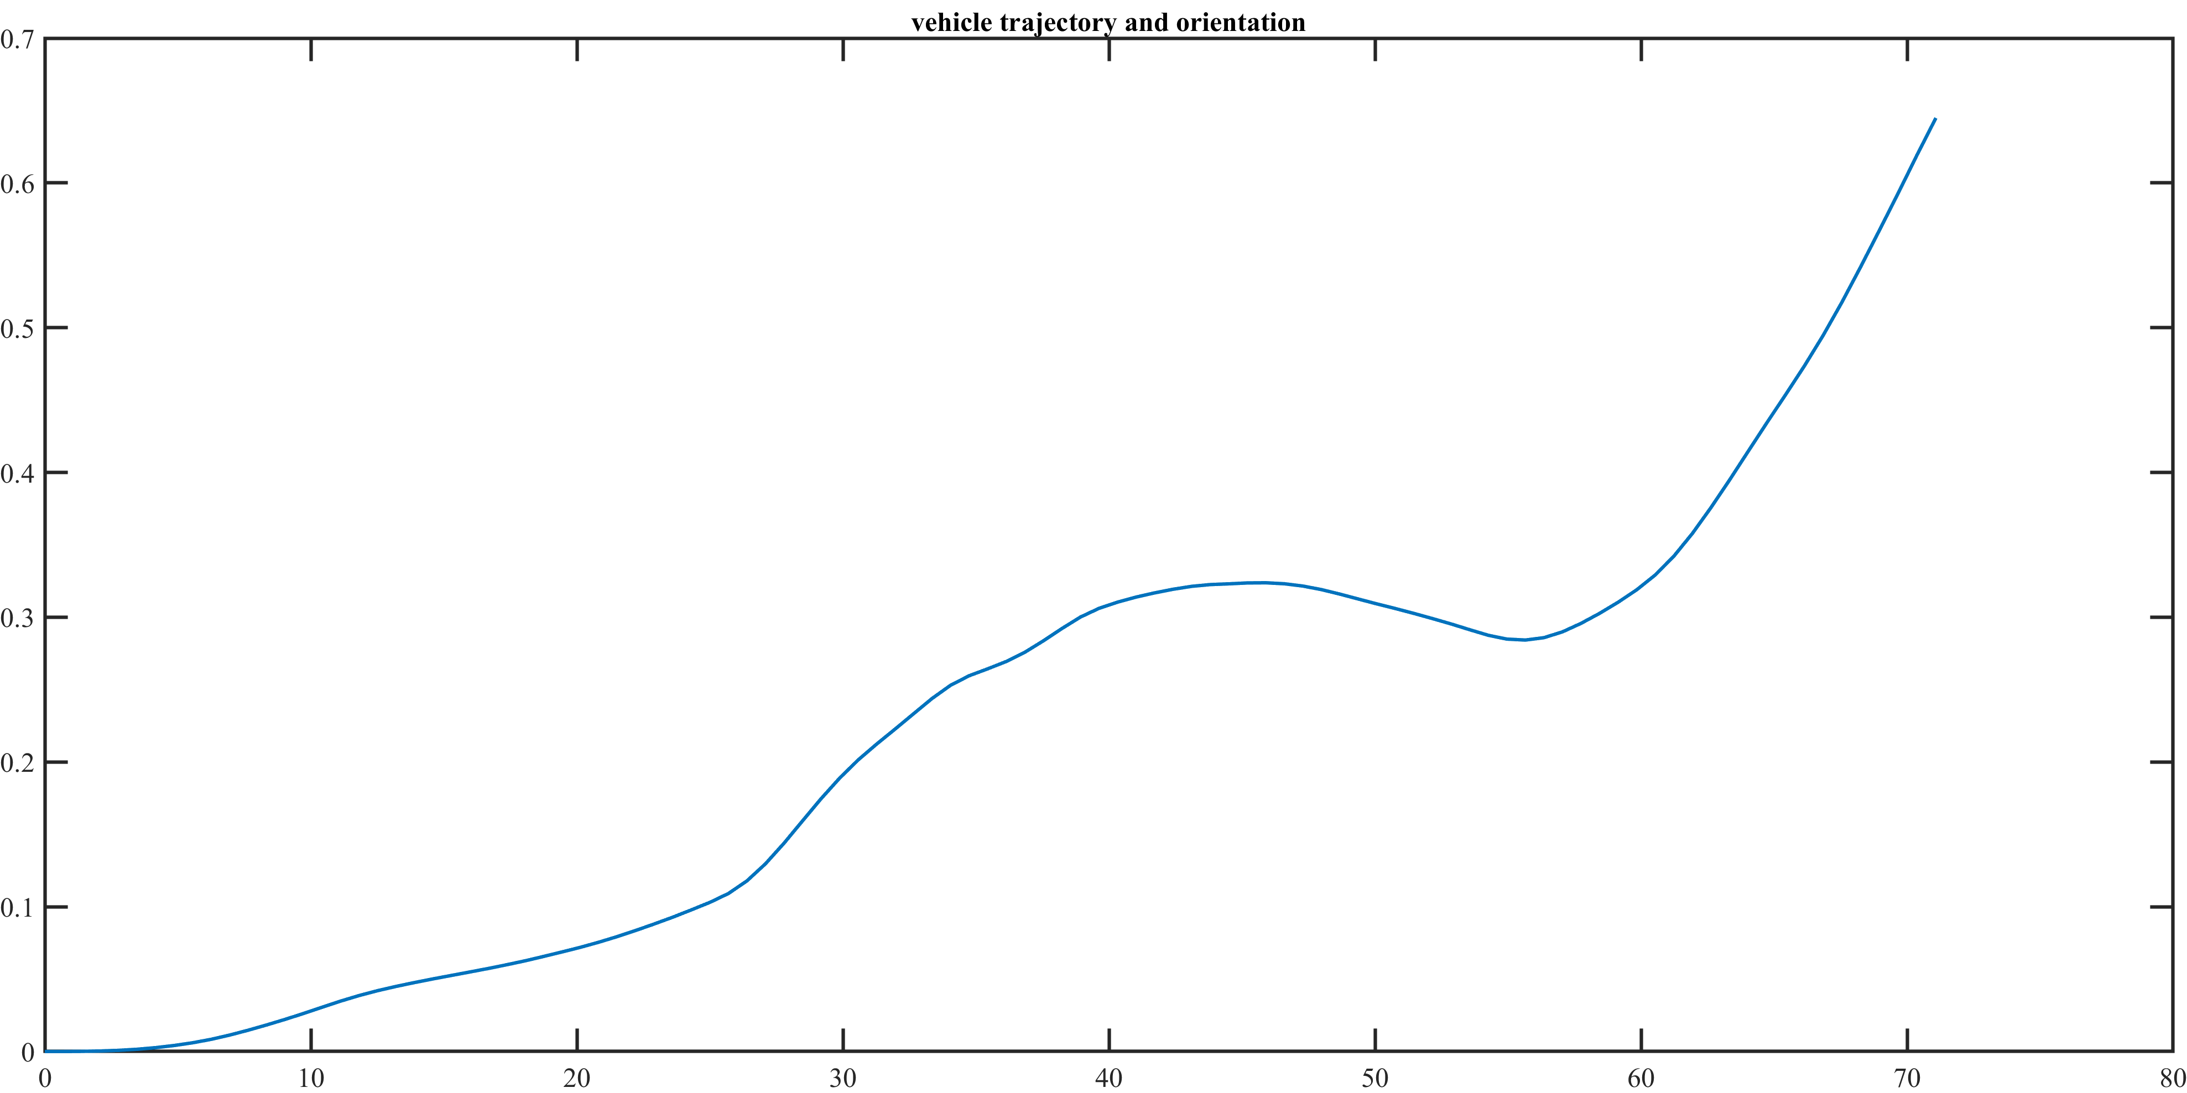

### Lambda = 0.25, Wet

In a wet condition but with the same loading condition we have rollover, but slightly after the dry condition (5 seconds): this is due to the lower intensity of the force that act on the truck wheels.

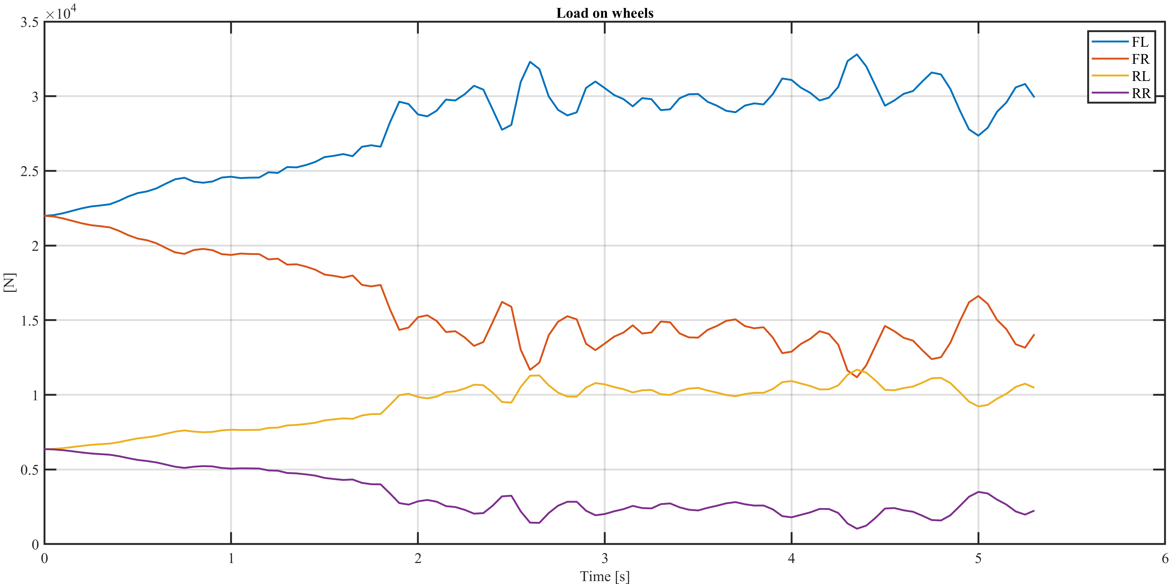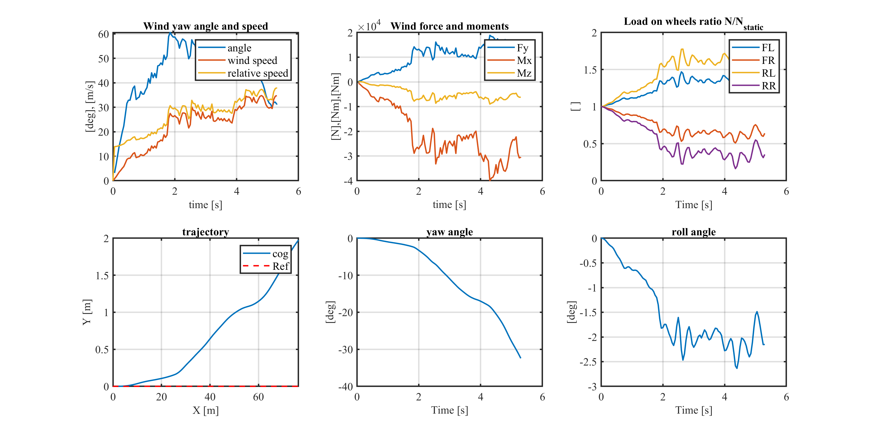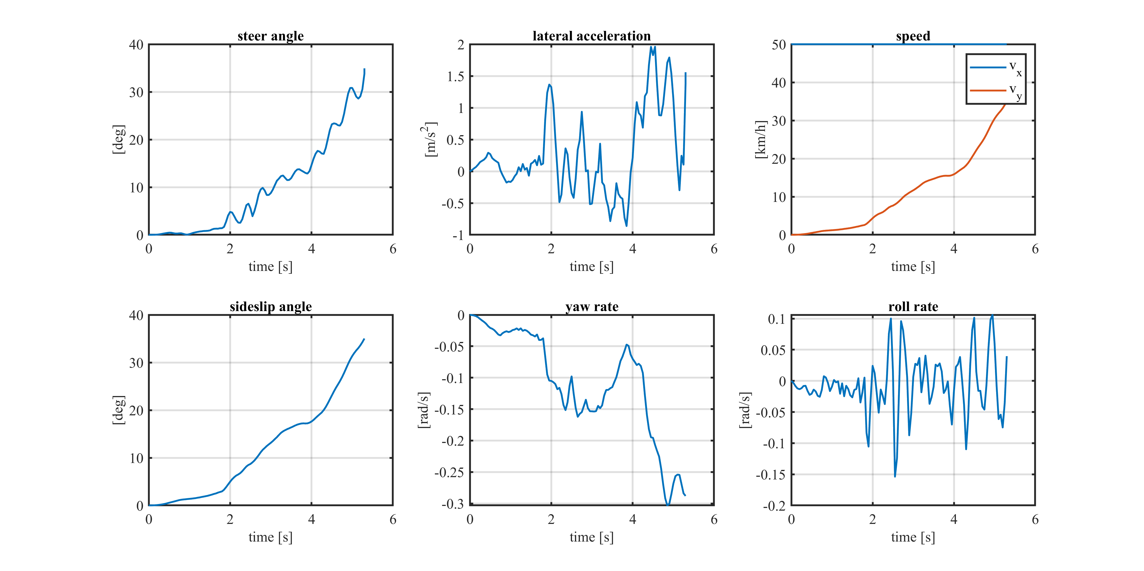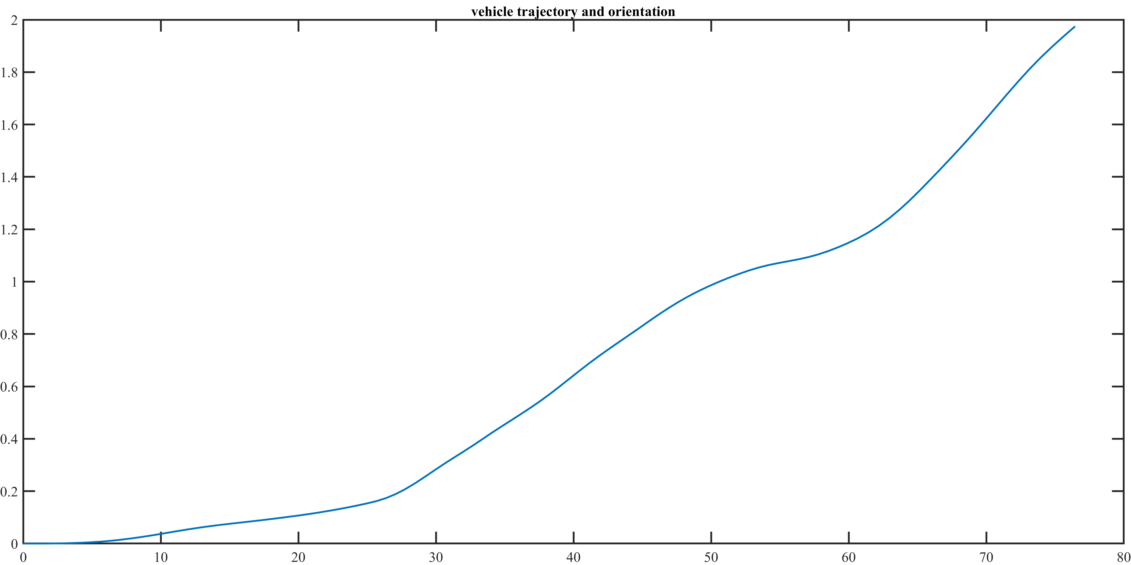

### Lambda = 0.25, Snow

In snow conditions, we have a rollover at a higher time than wet conditions. However, this is a very dangerous situation: the steer angle is arrived at its end excursion (45 degrees), the wind is so strong and the snow on the street reduce the intensity of the forces acting on the wheels.

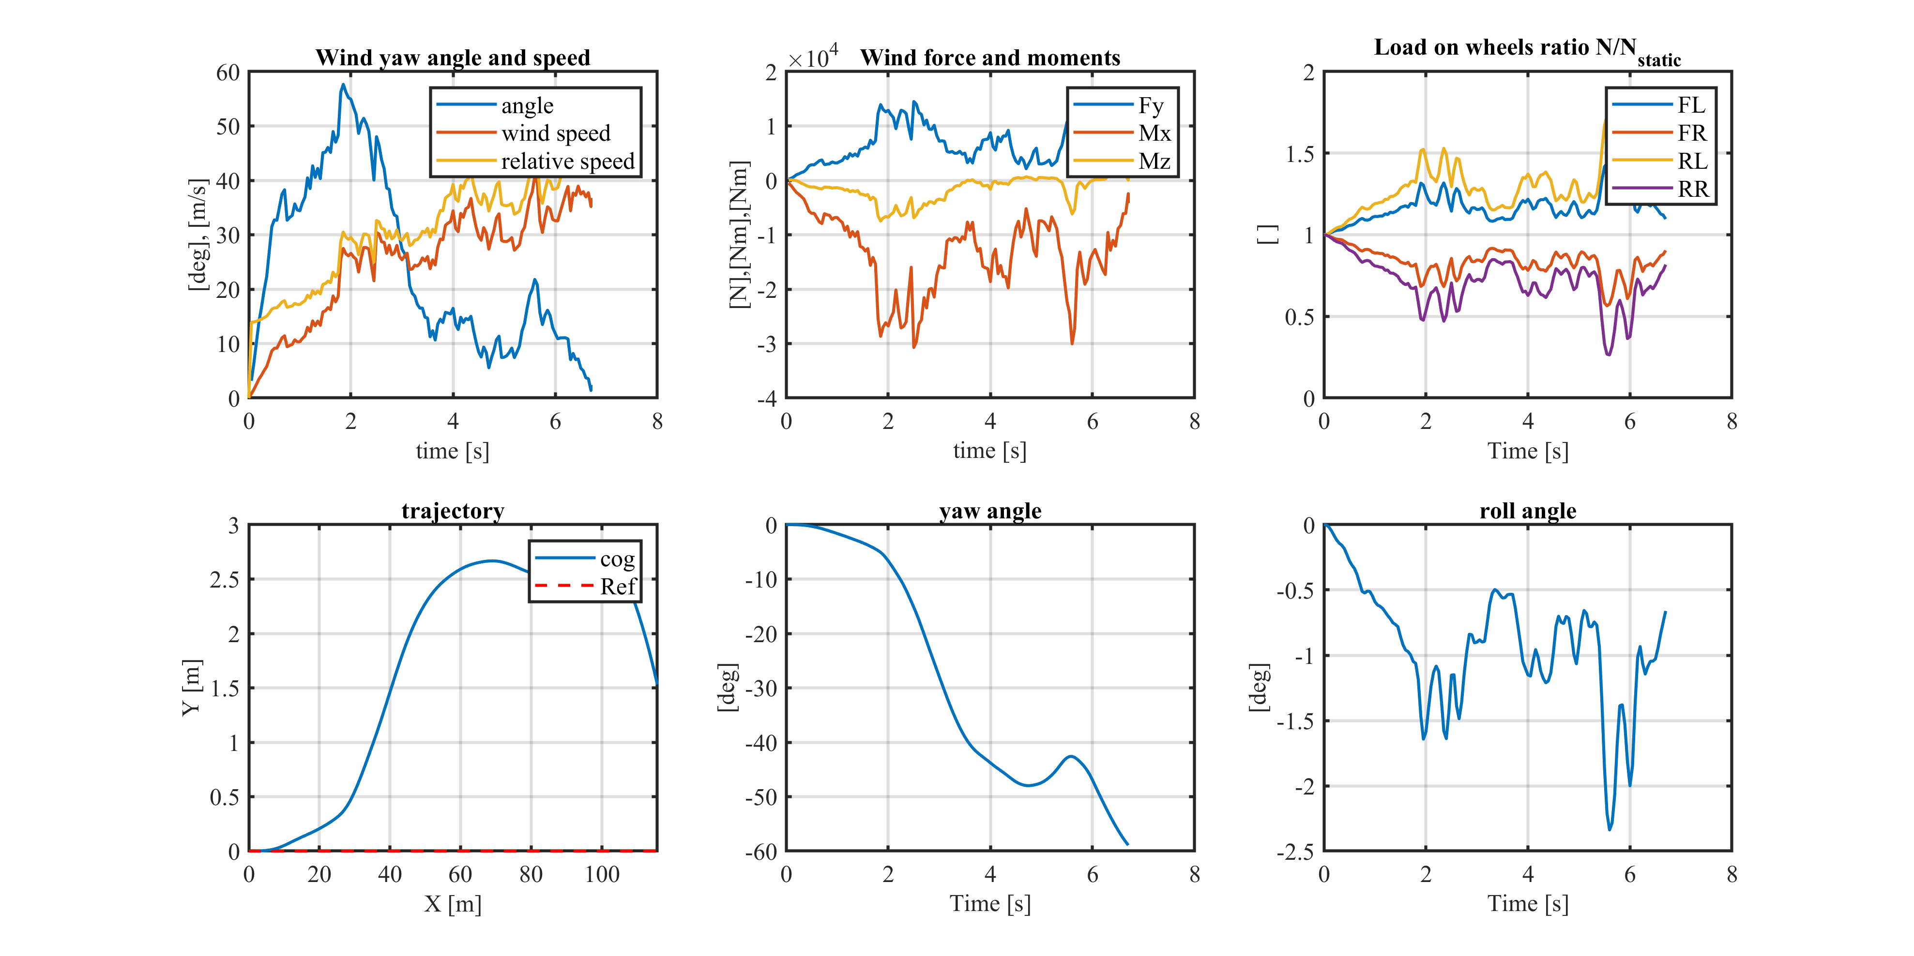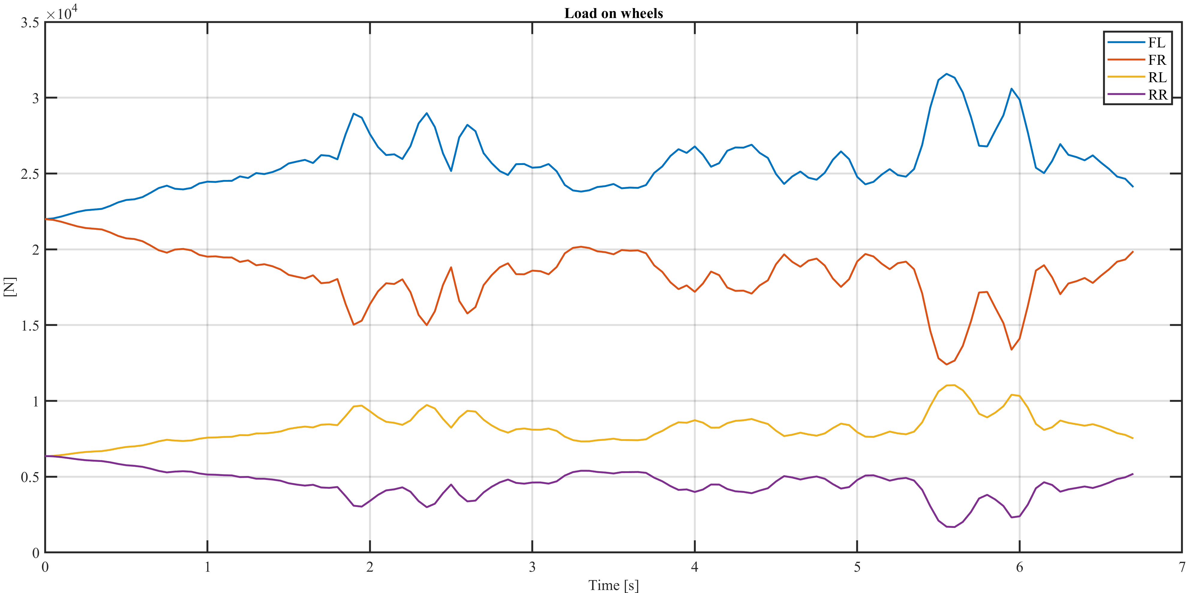

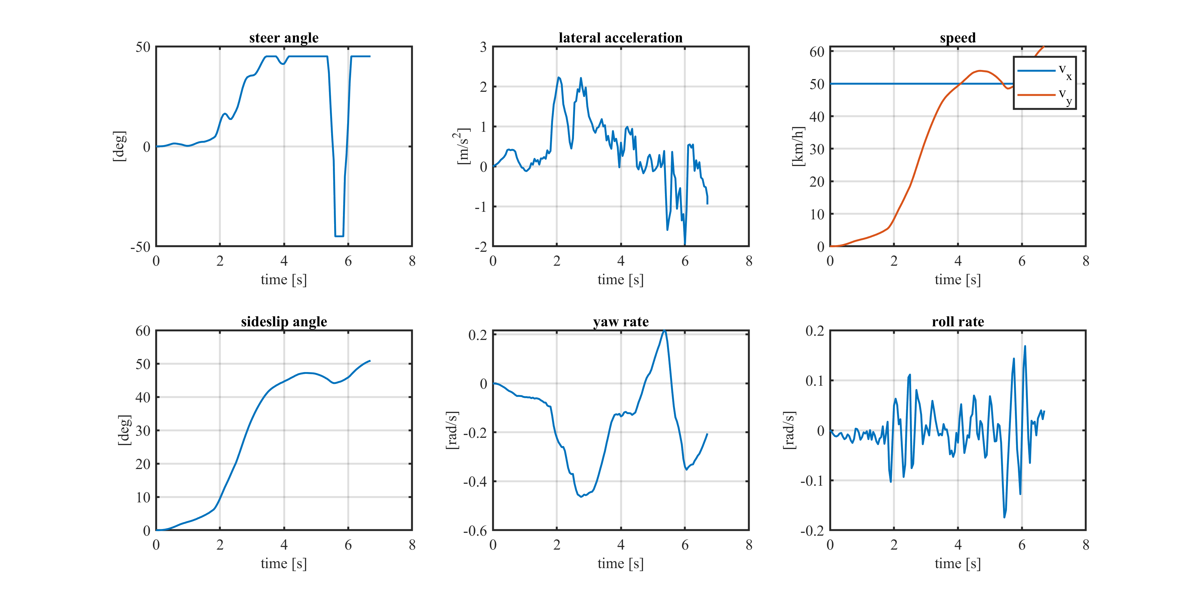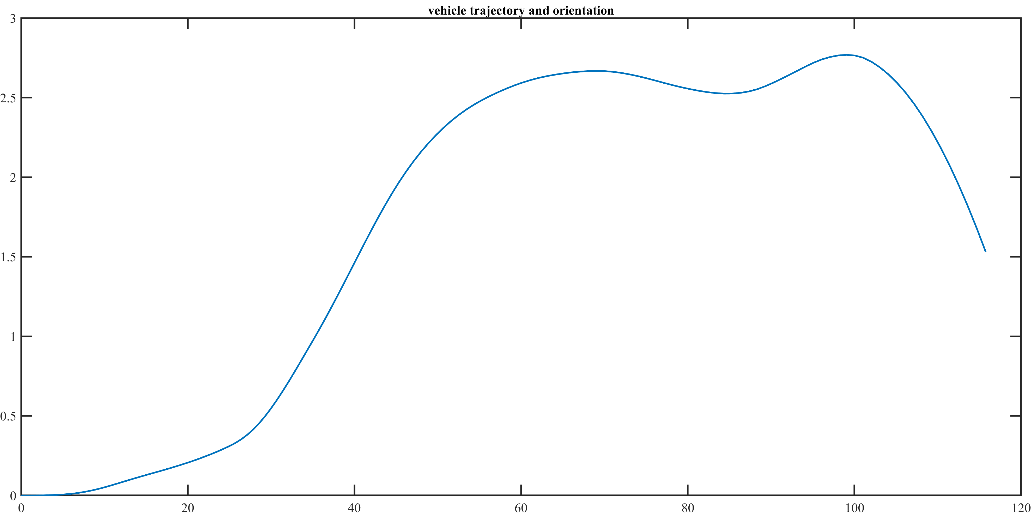

### Lambda = 0.5, Dry

Here we consider a half loaded truck: rollover does not occur but we are very close to this condition. If the road manager decided to adopt a safety margin to allow truck on this road, probably trucks would not be allowed in this wind condition.

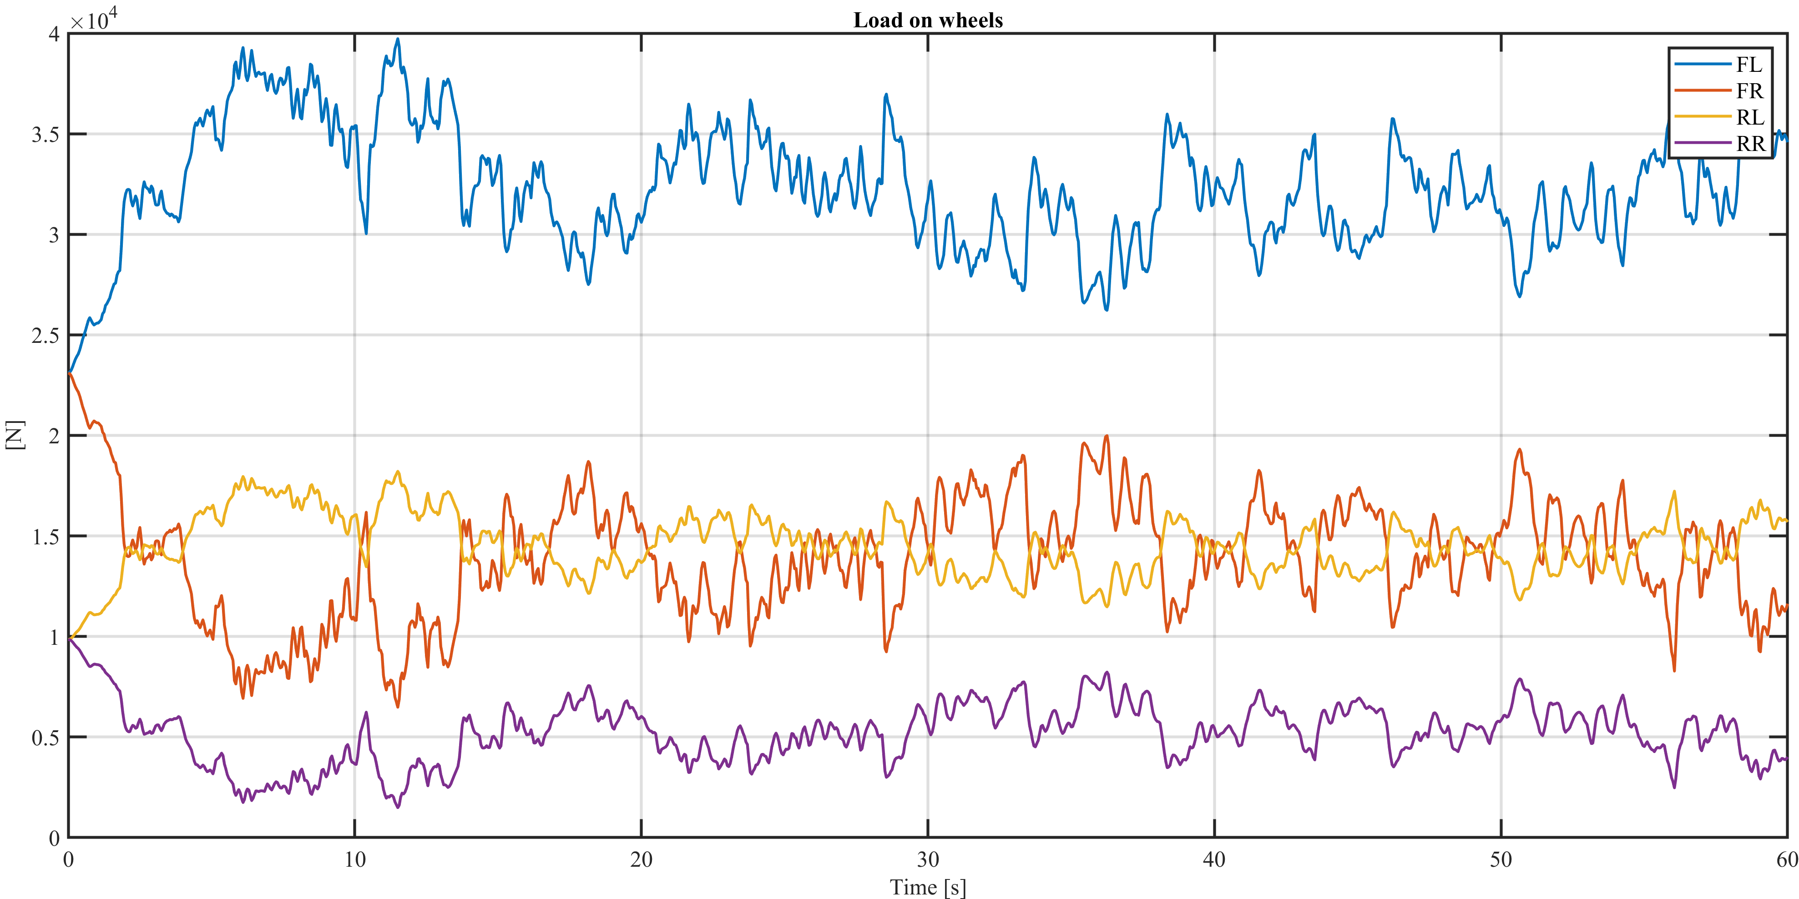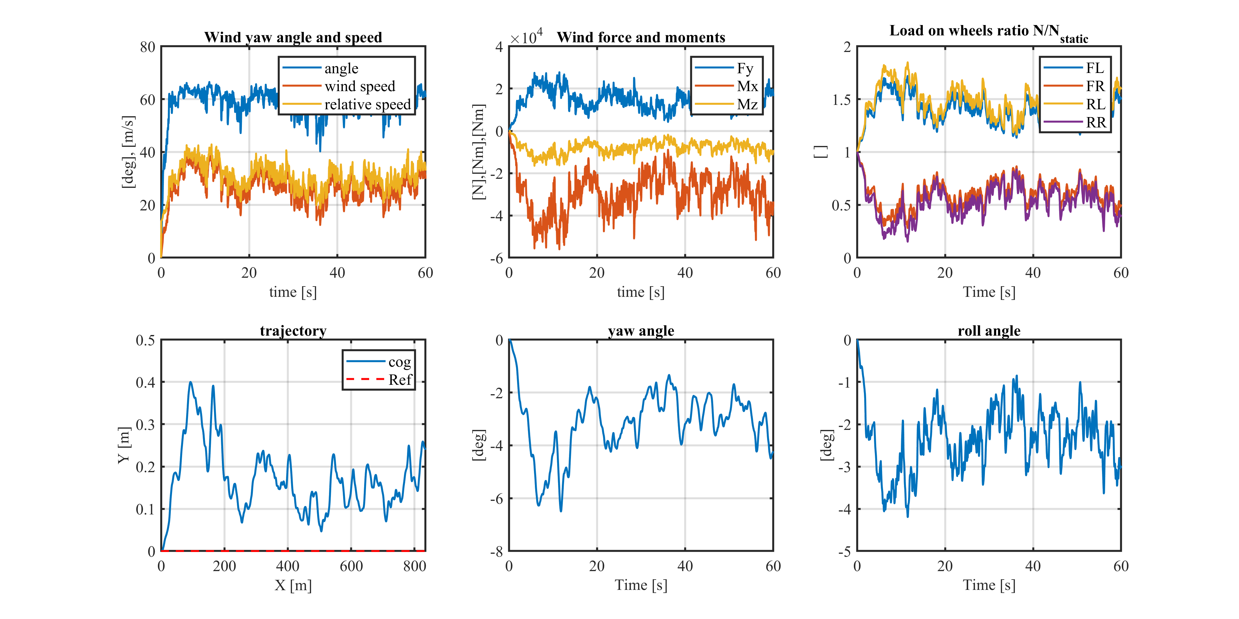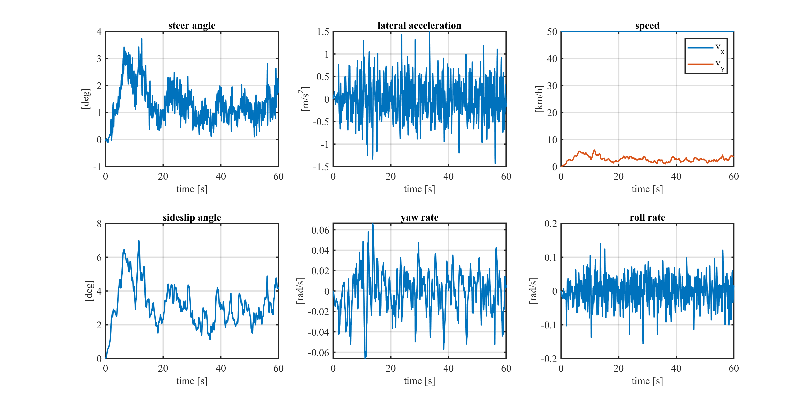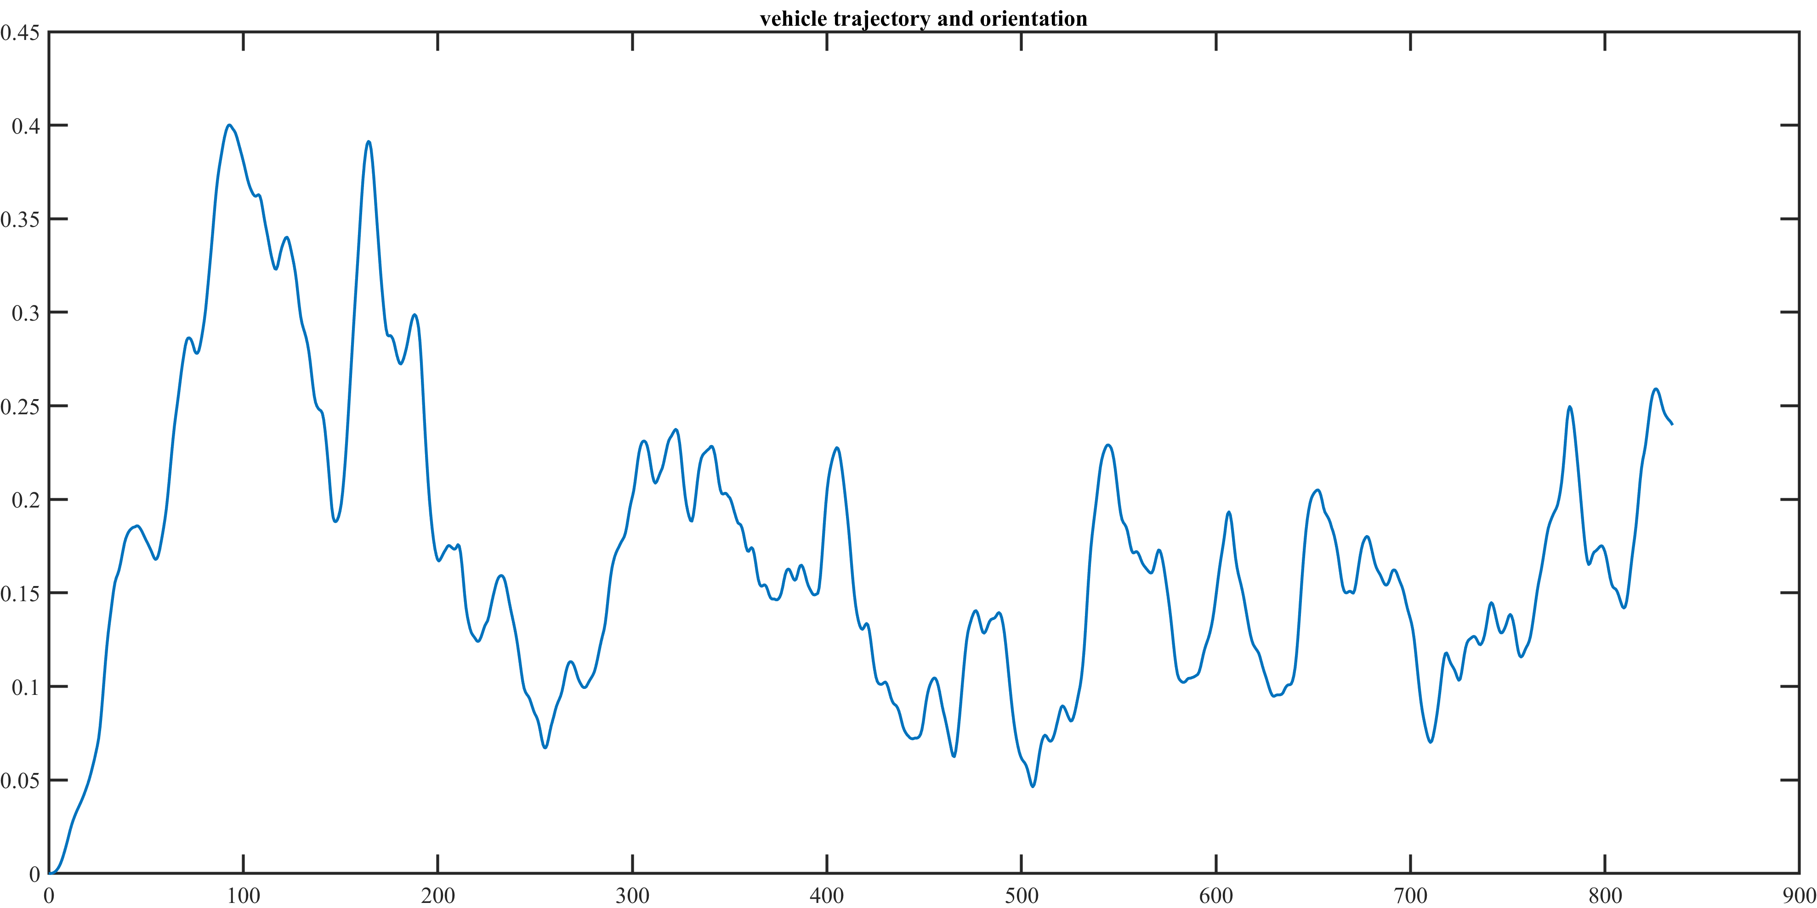

### Lambda = 0.5 Wet

Also in this case roll over does not occur but we are very close. Moreover, at the begin of the simulation the truck is displaced a lot by the wind, the situation is very dangerous and trucks should not circulate.

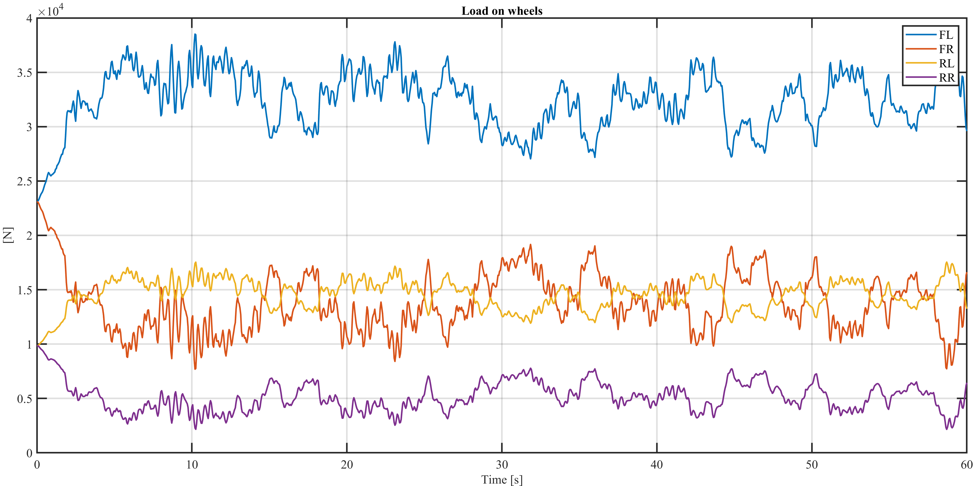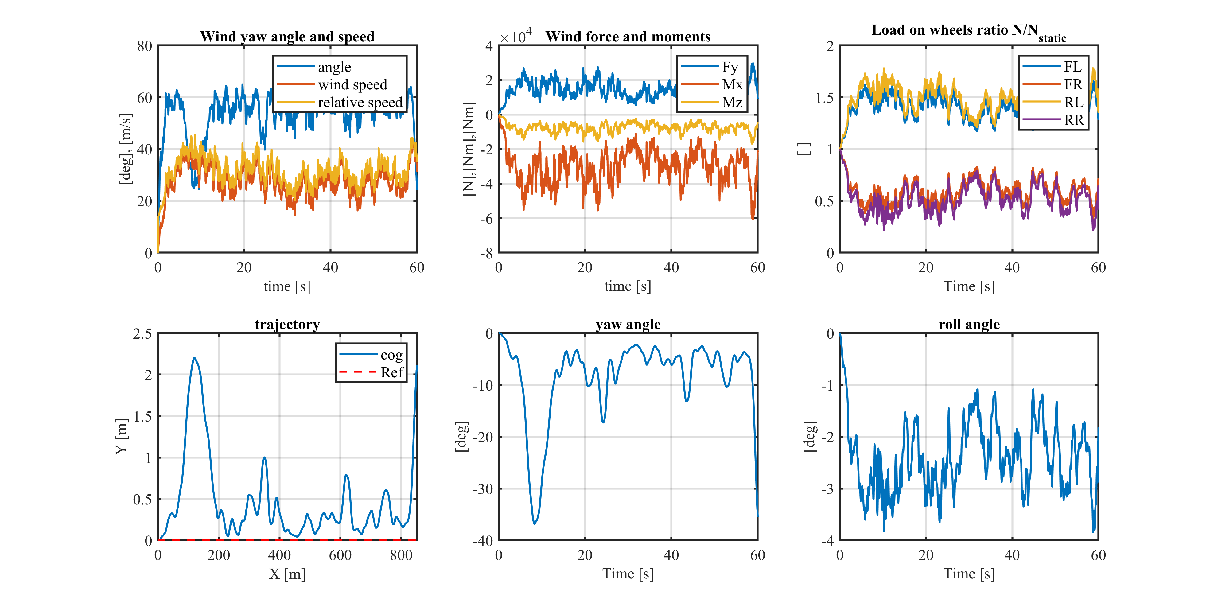

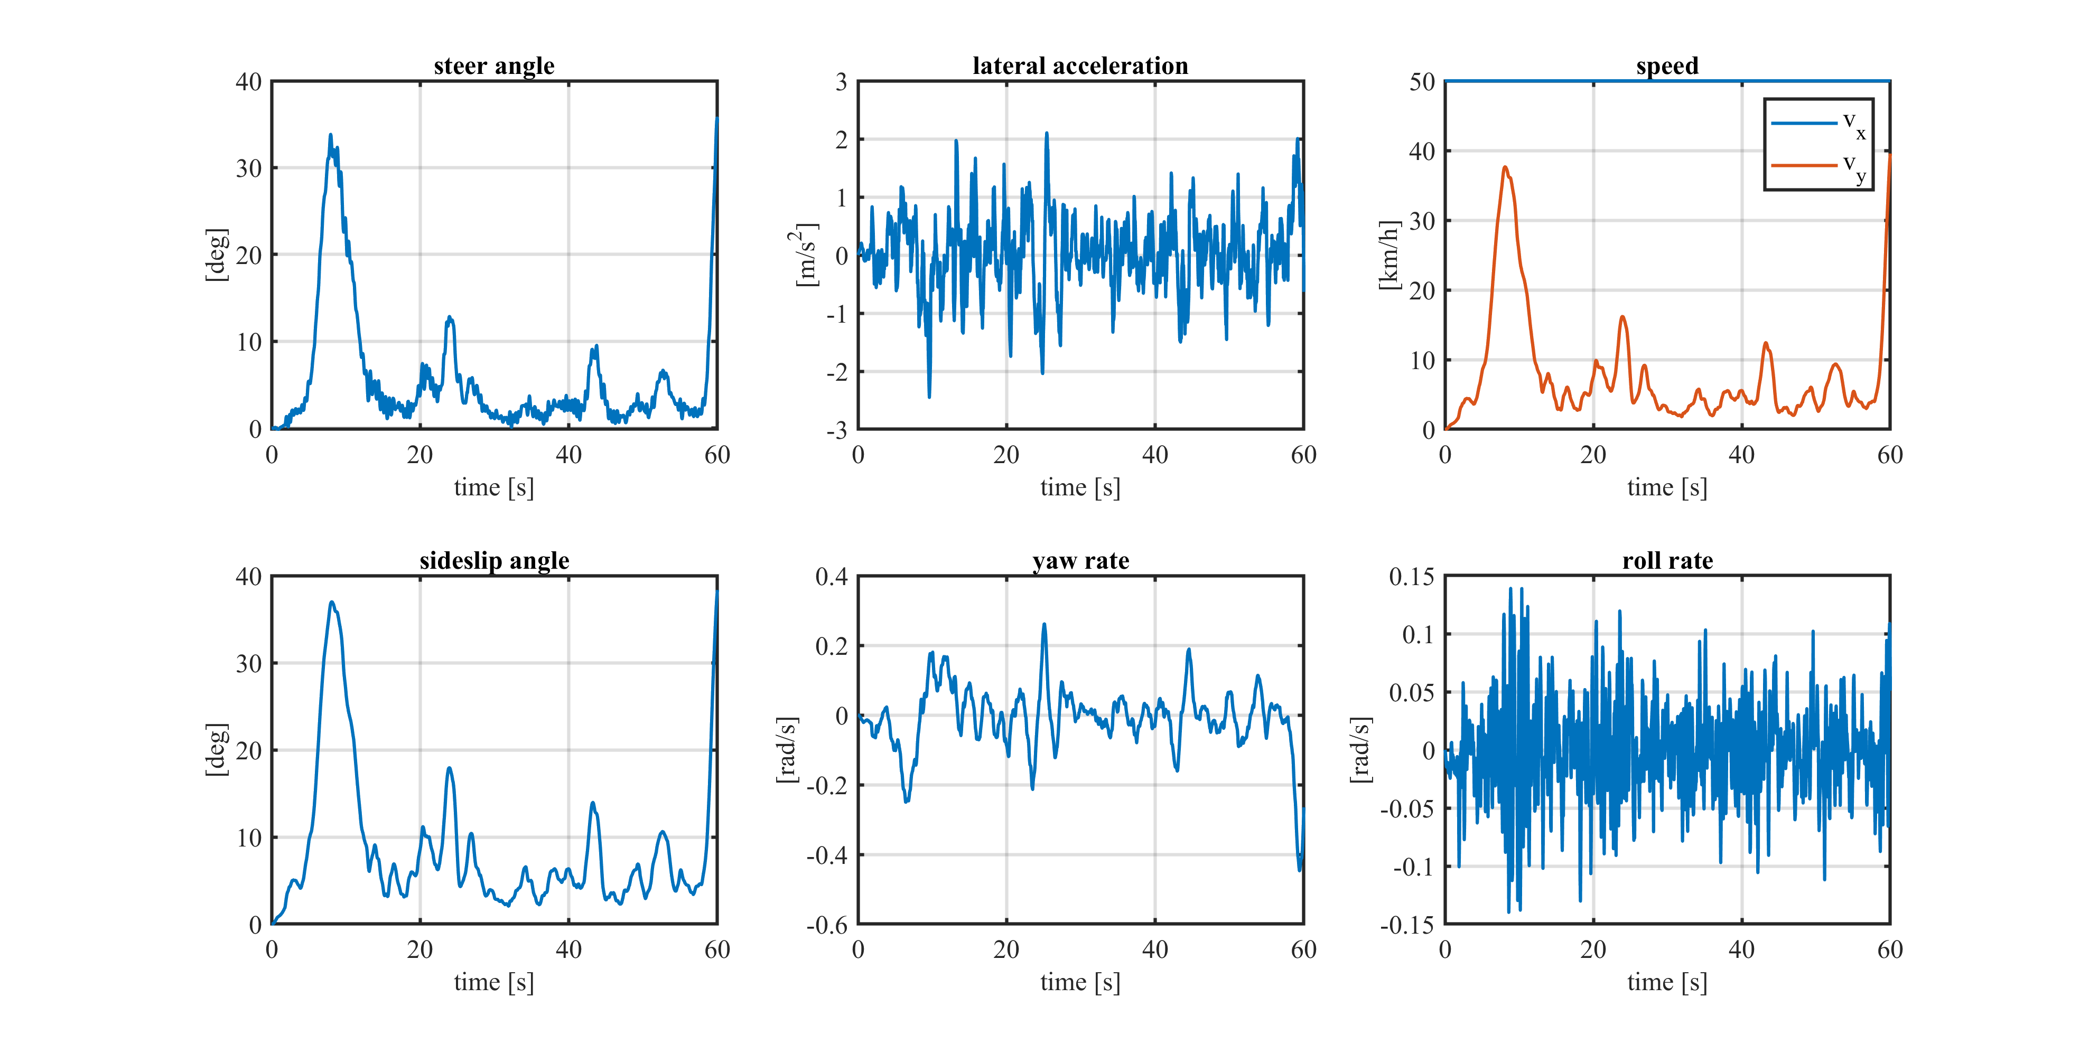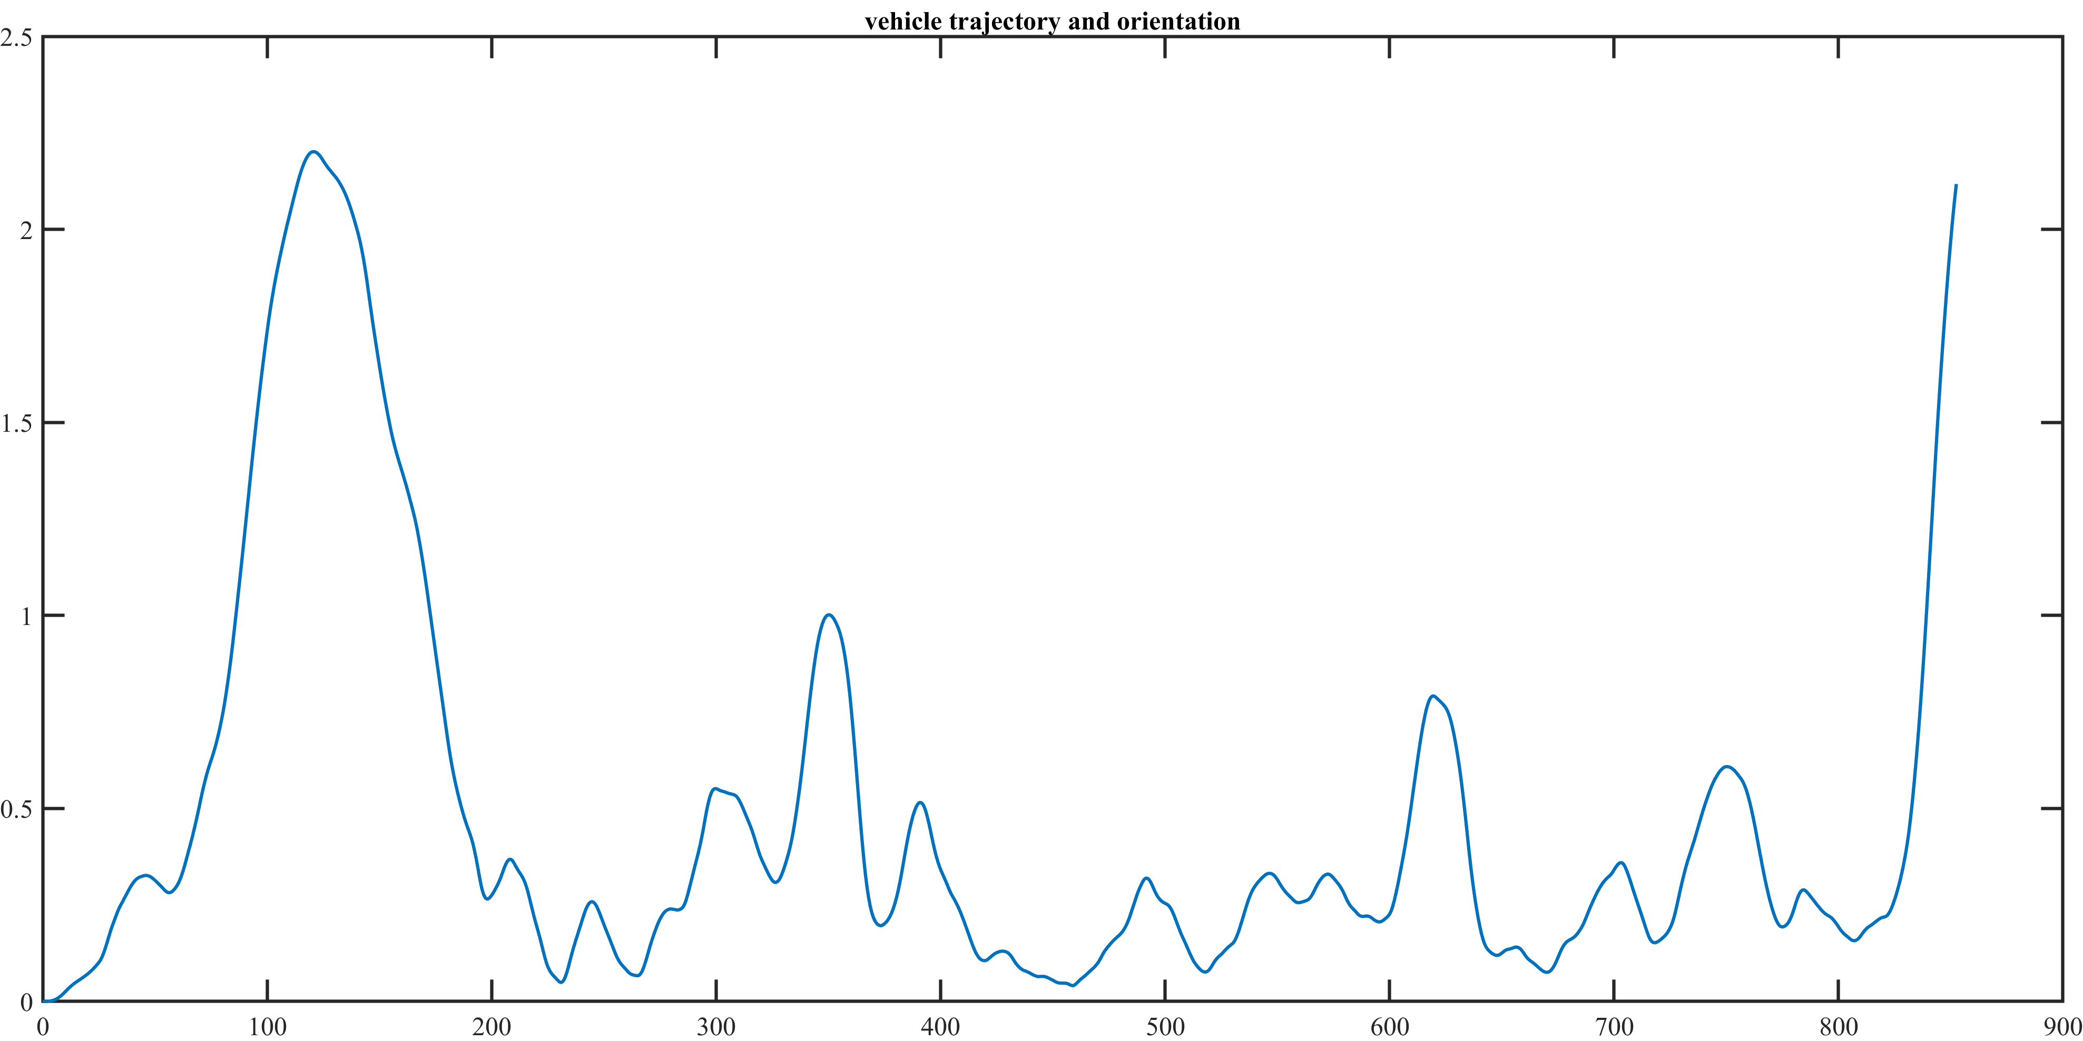

### Lambda = 0.5, Snow

This is a very critic condition since roll over does not occur but the truck leaves the road, as it can be seen in the trajectory figure (for this reason the simulation is stopped due to a numerical error).

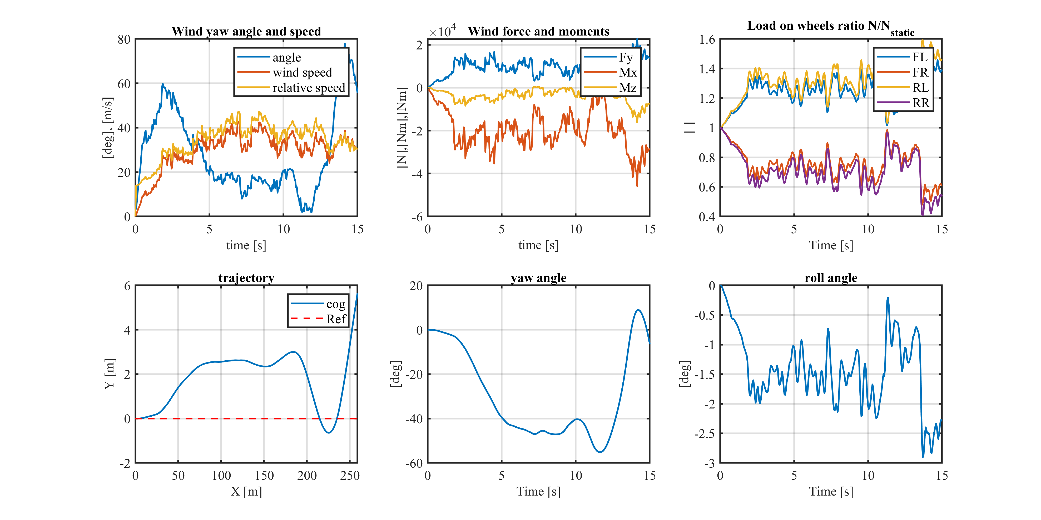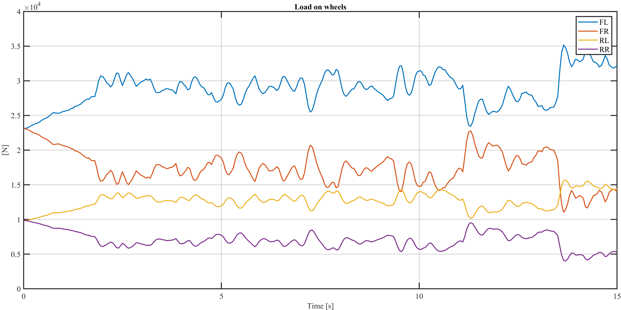

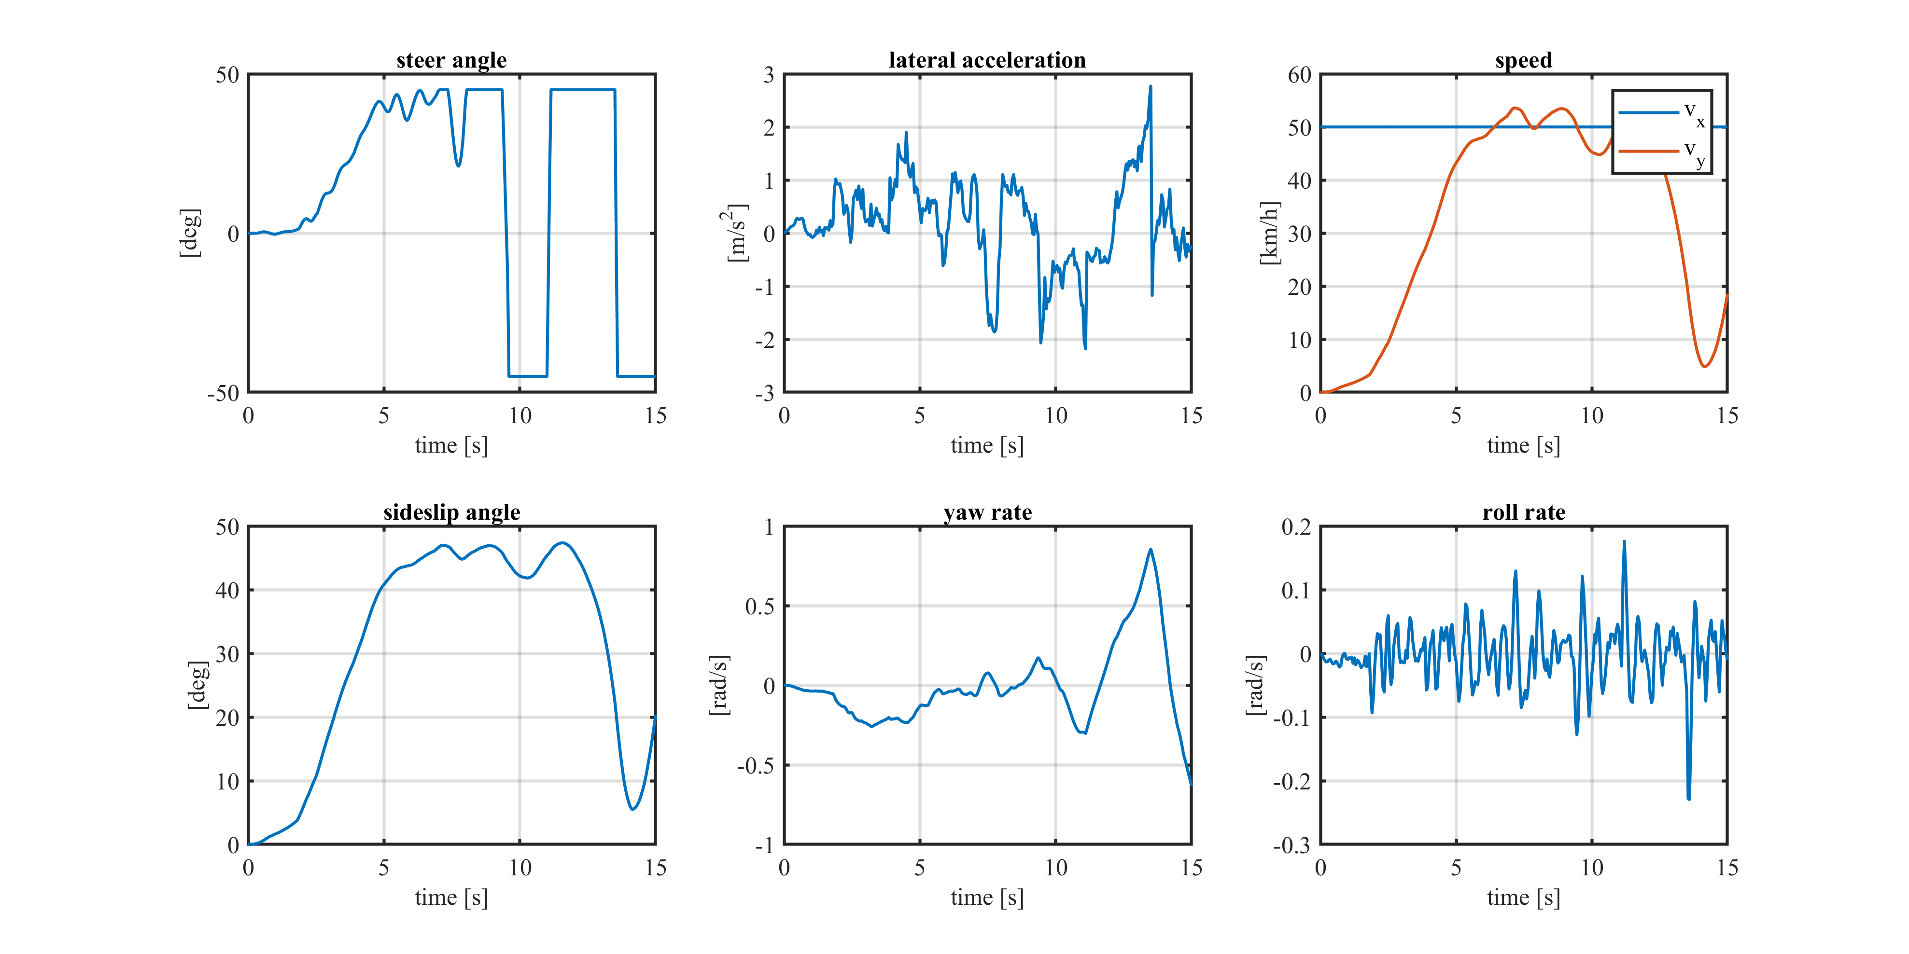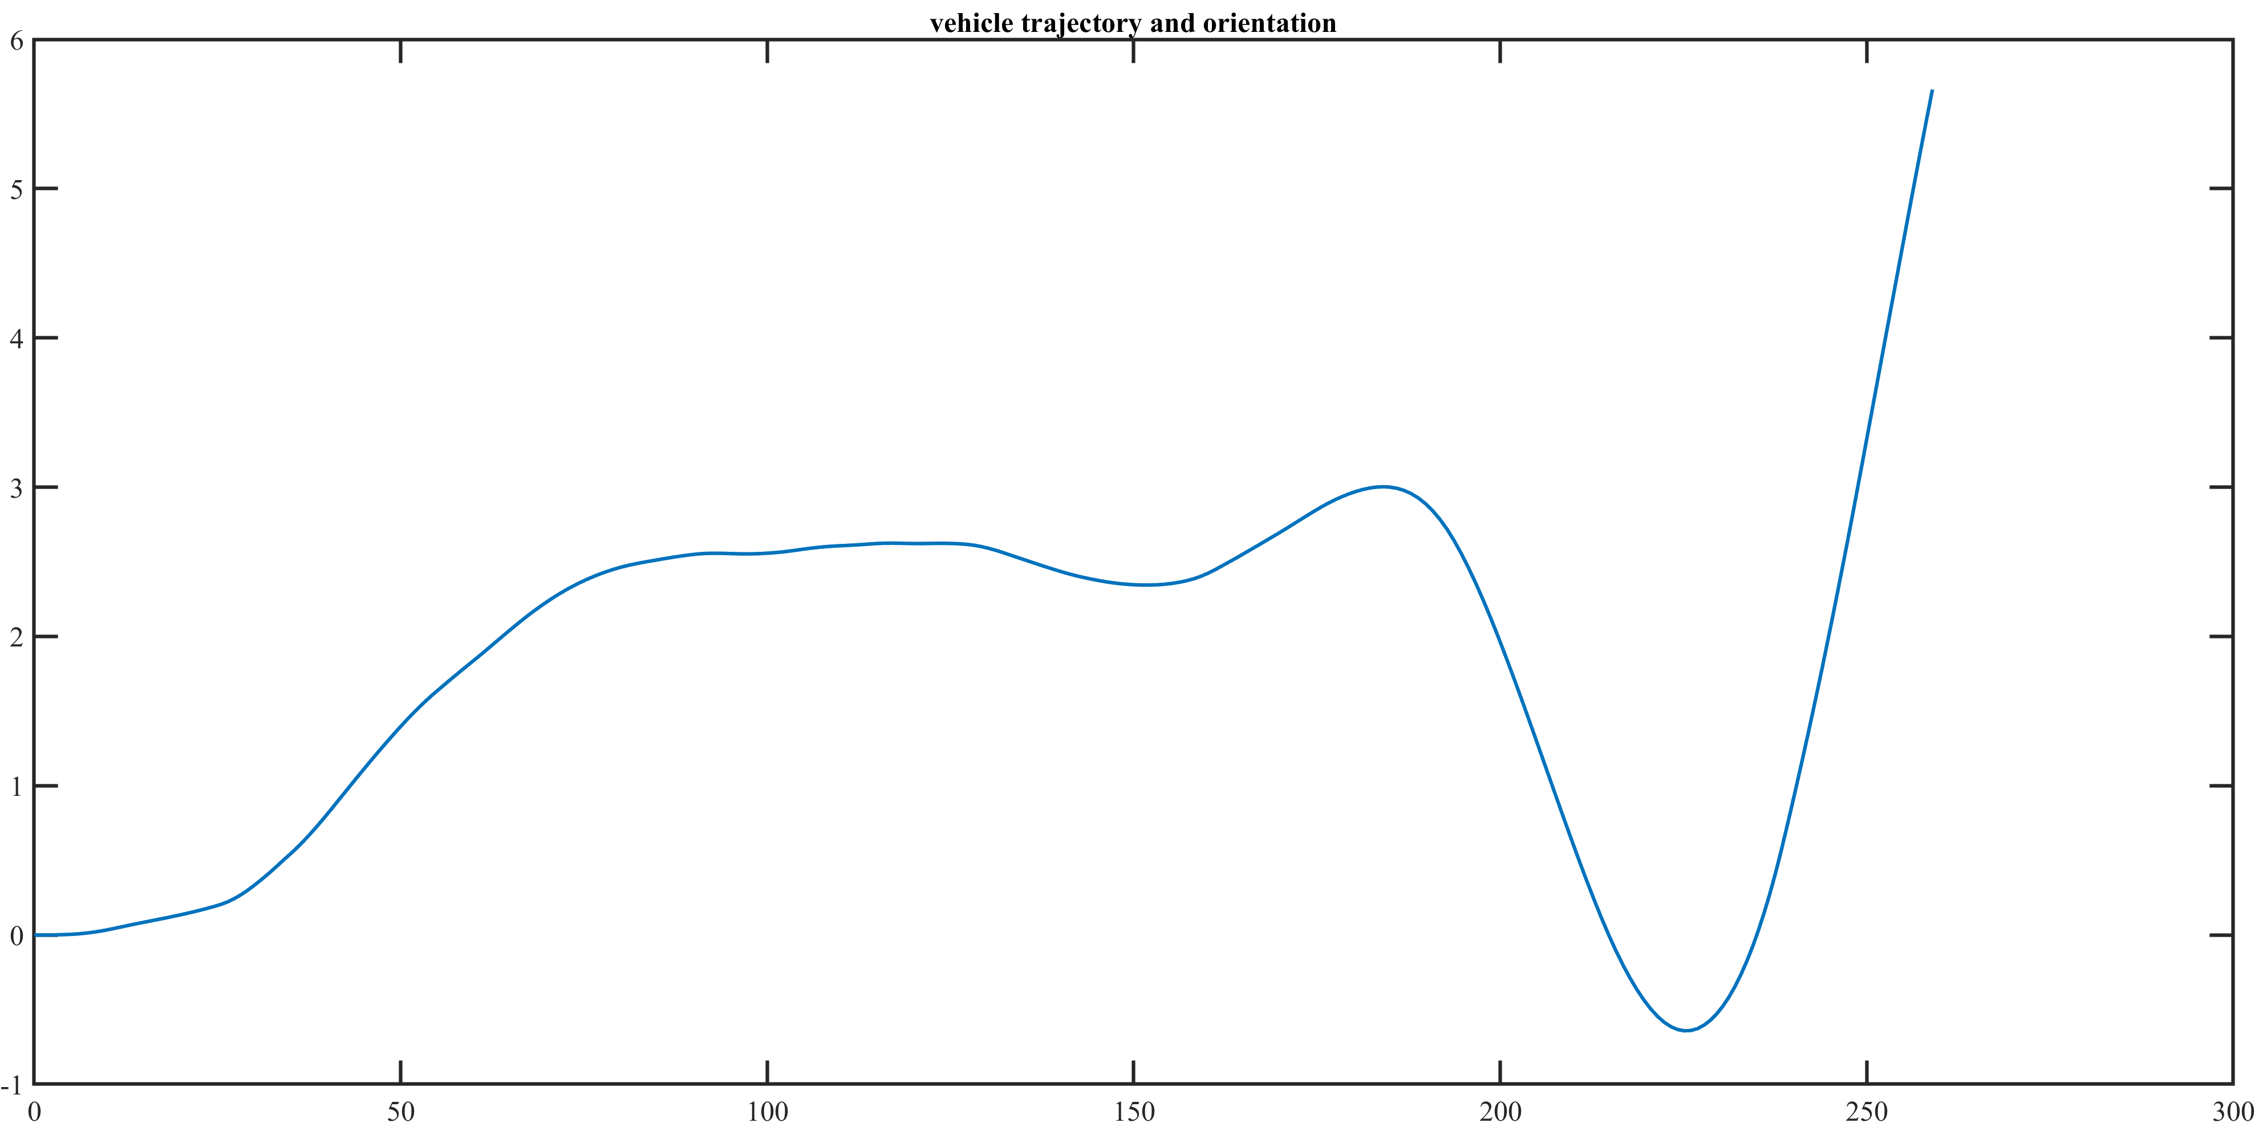

### Lambda = 0.75, Dry

Now we are at ¾ of the maximum capacity of the truck. We are now in a safe condition.

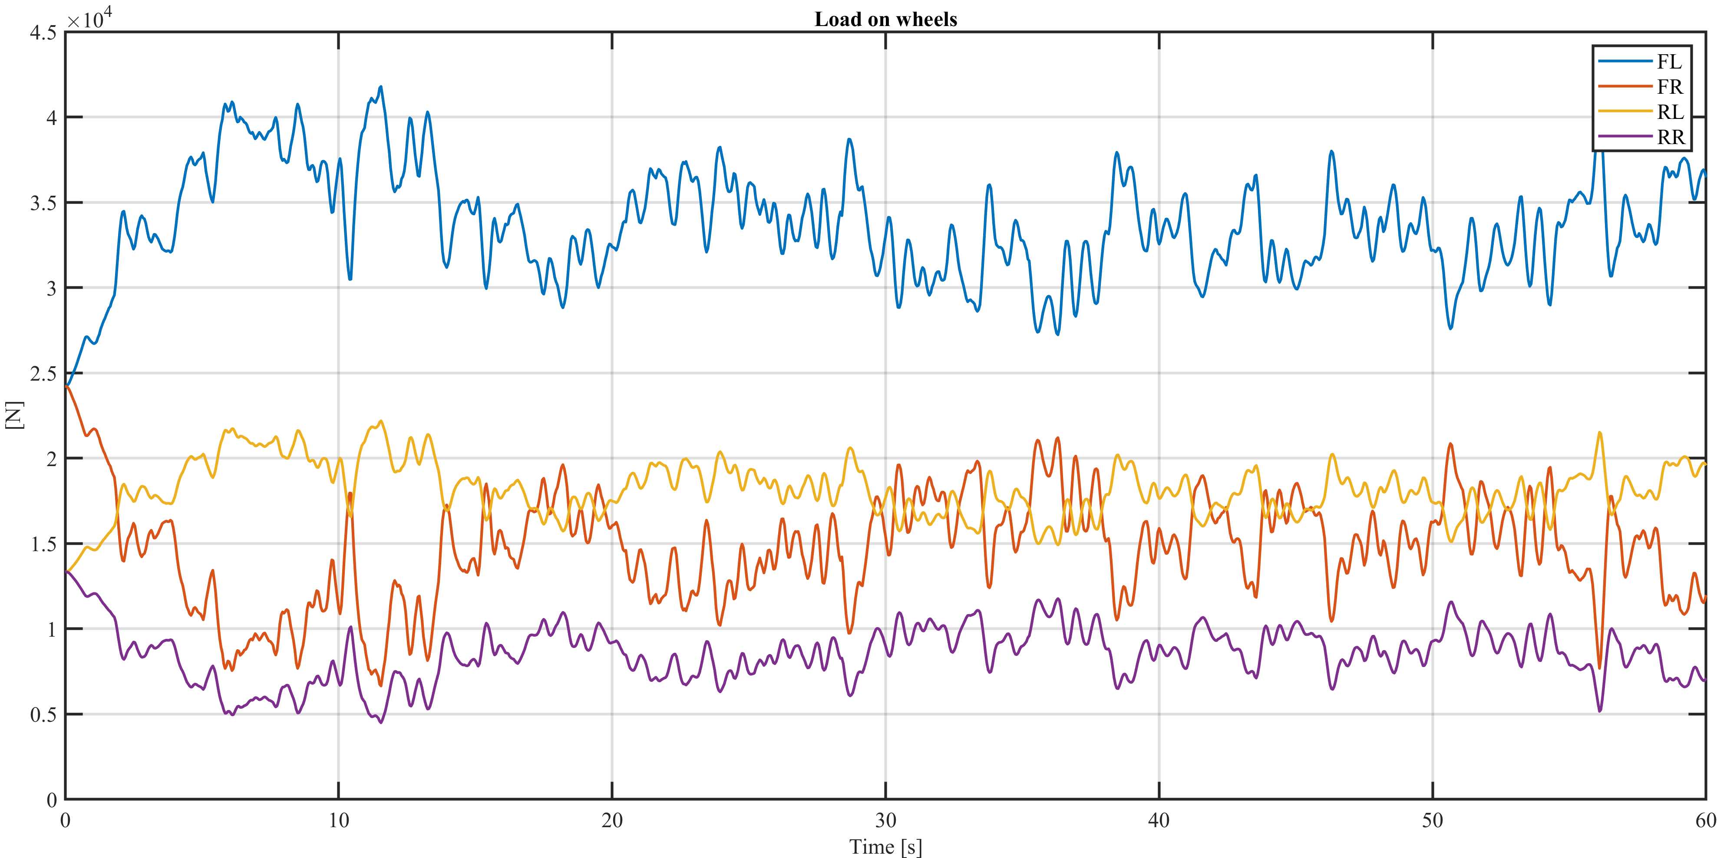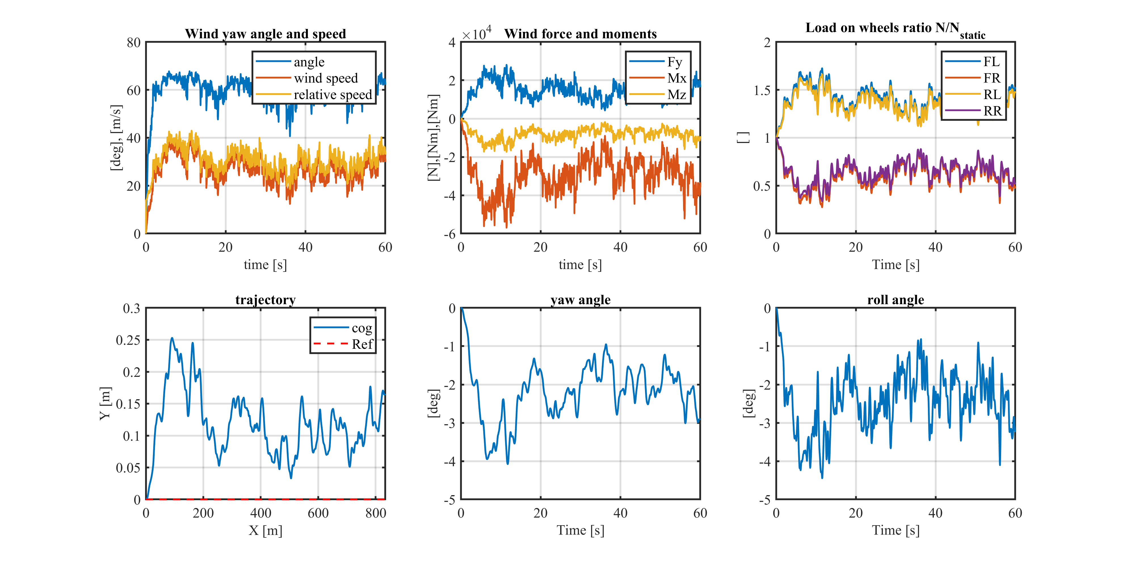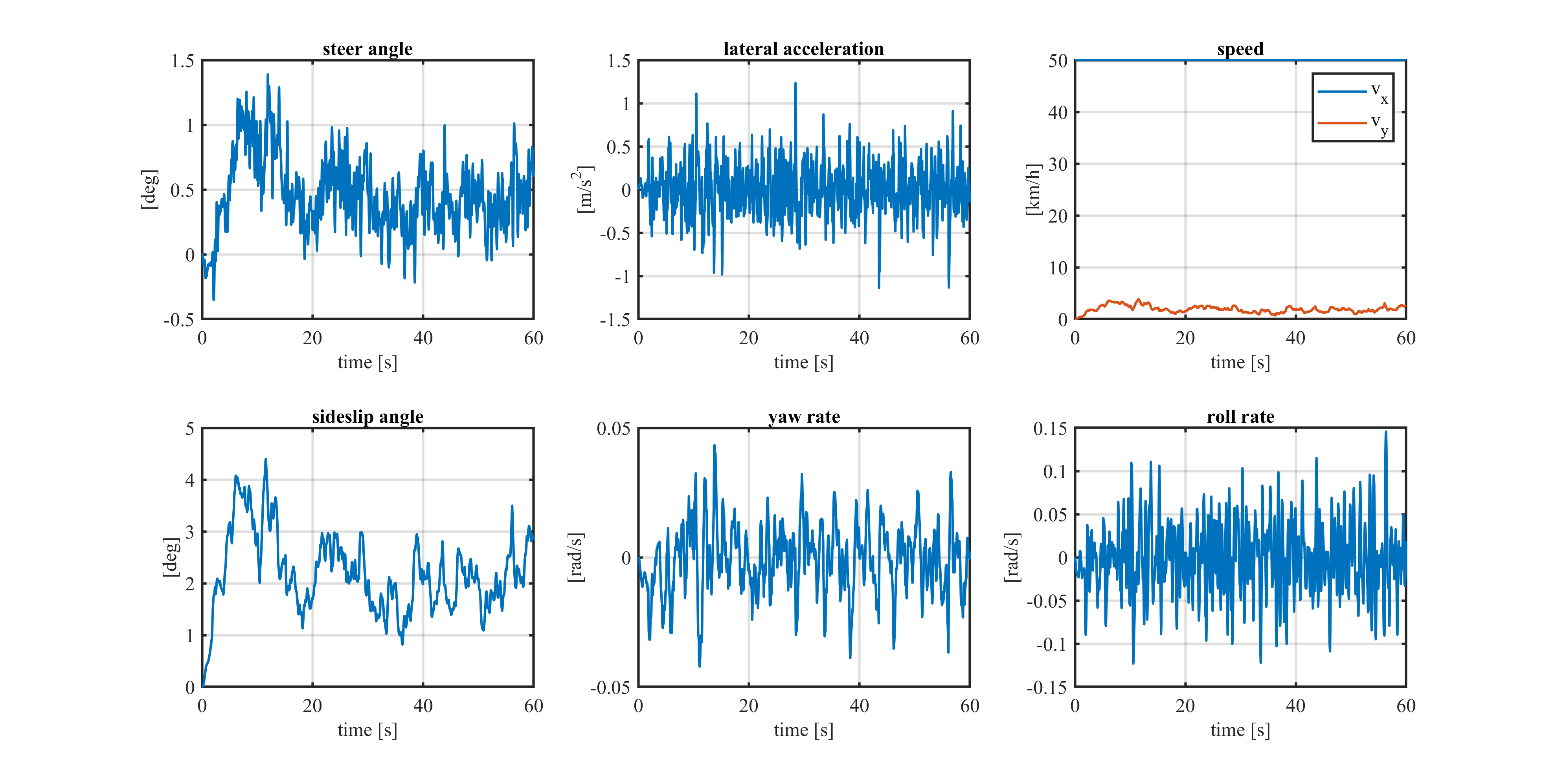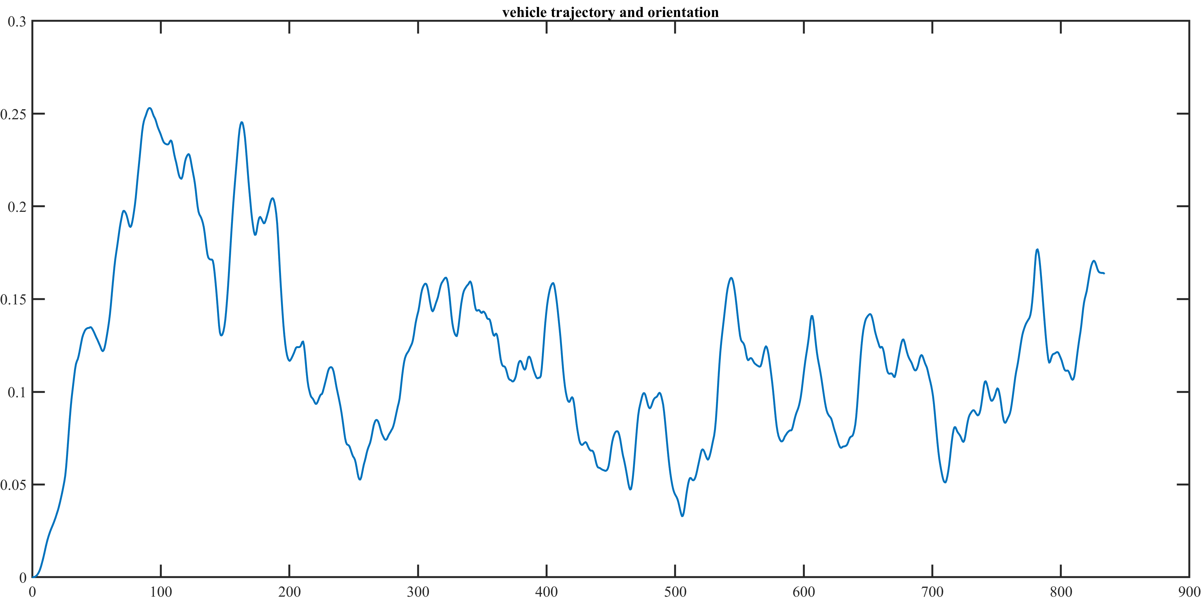

### Lambda = 0.75, Wet

Also in this case we are in a safe condition.

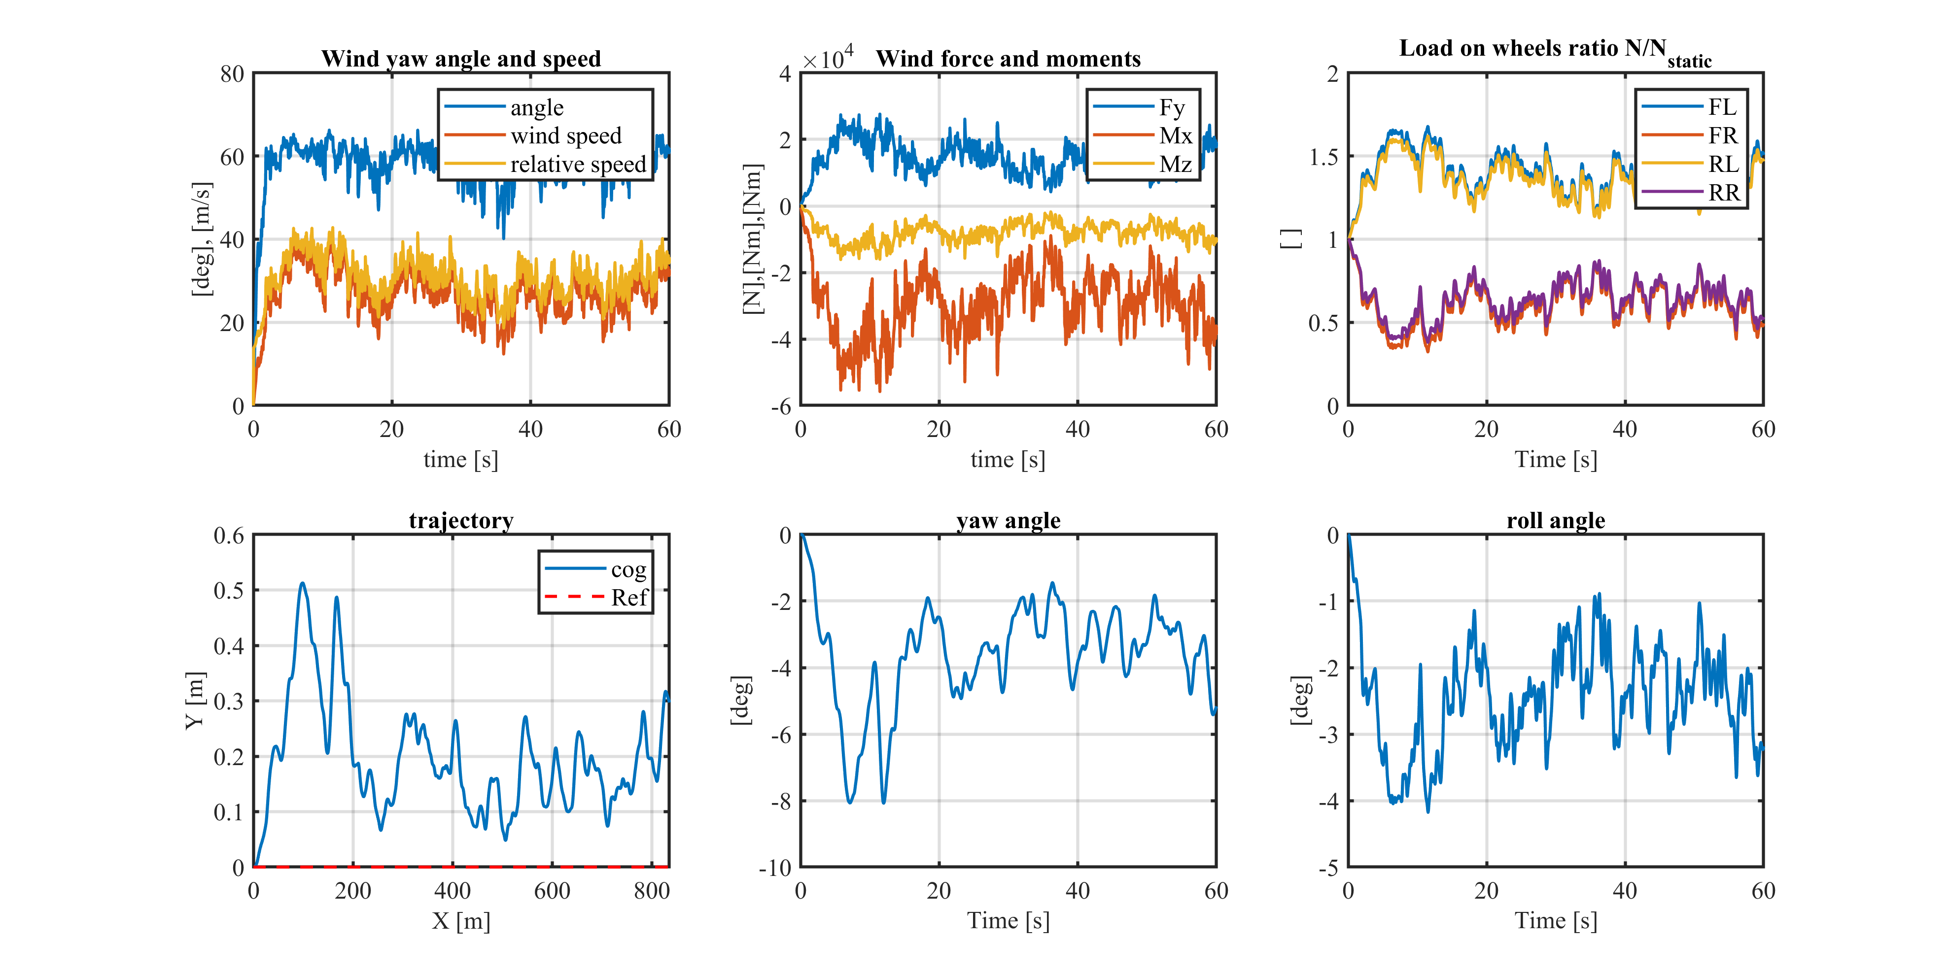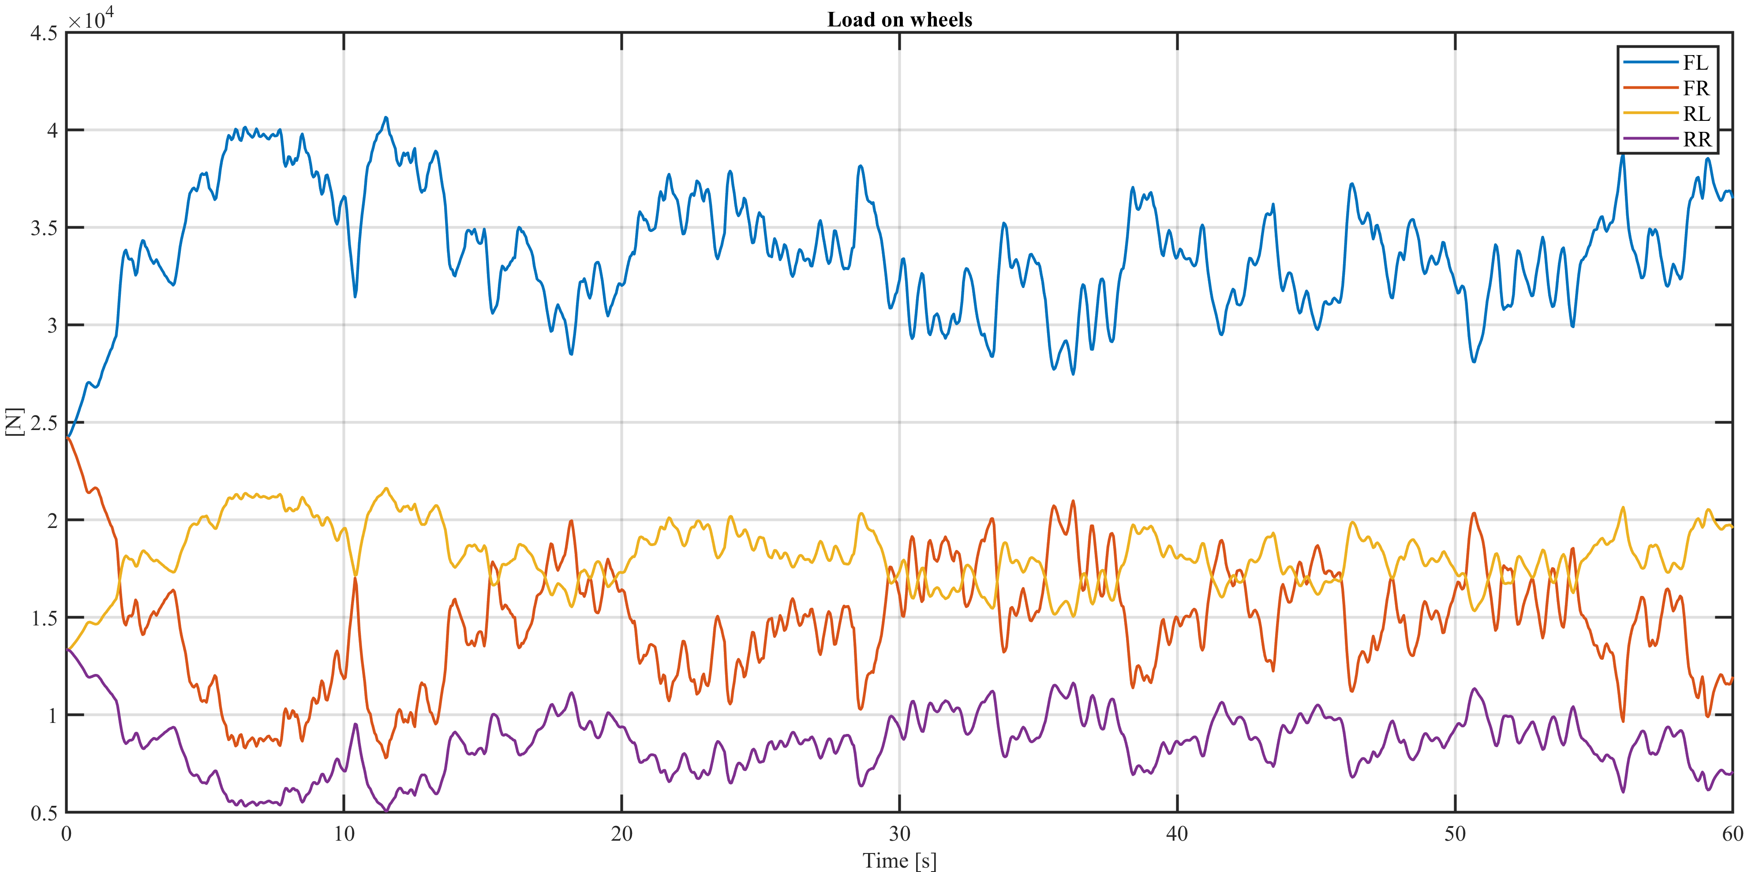

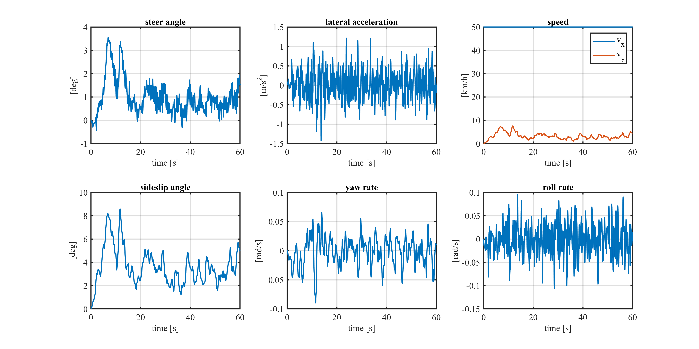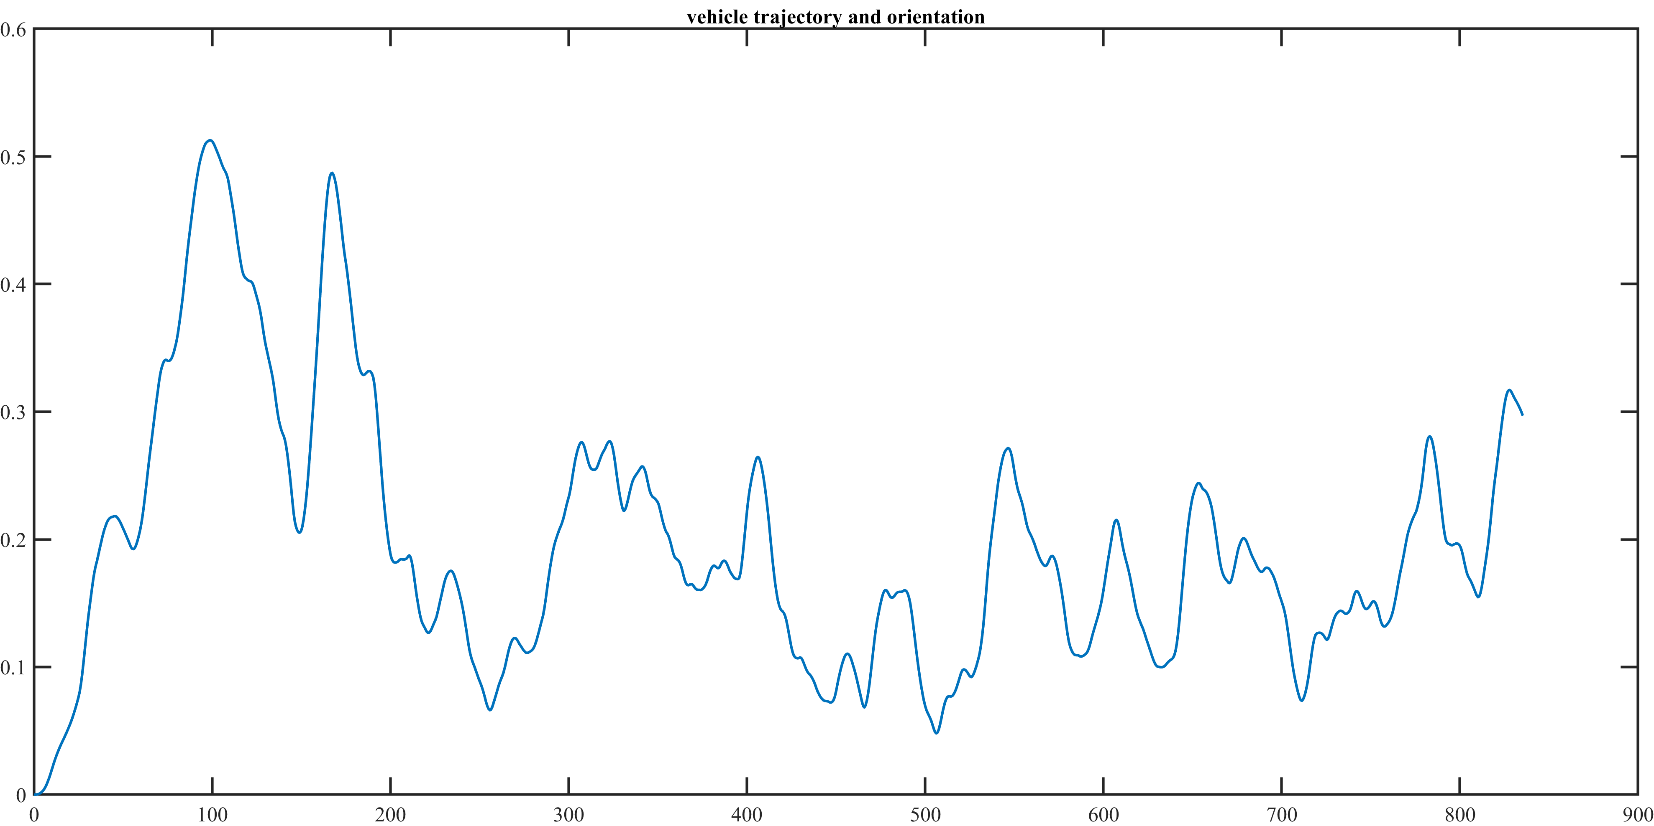

### Lambda = 0.75, Snow

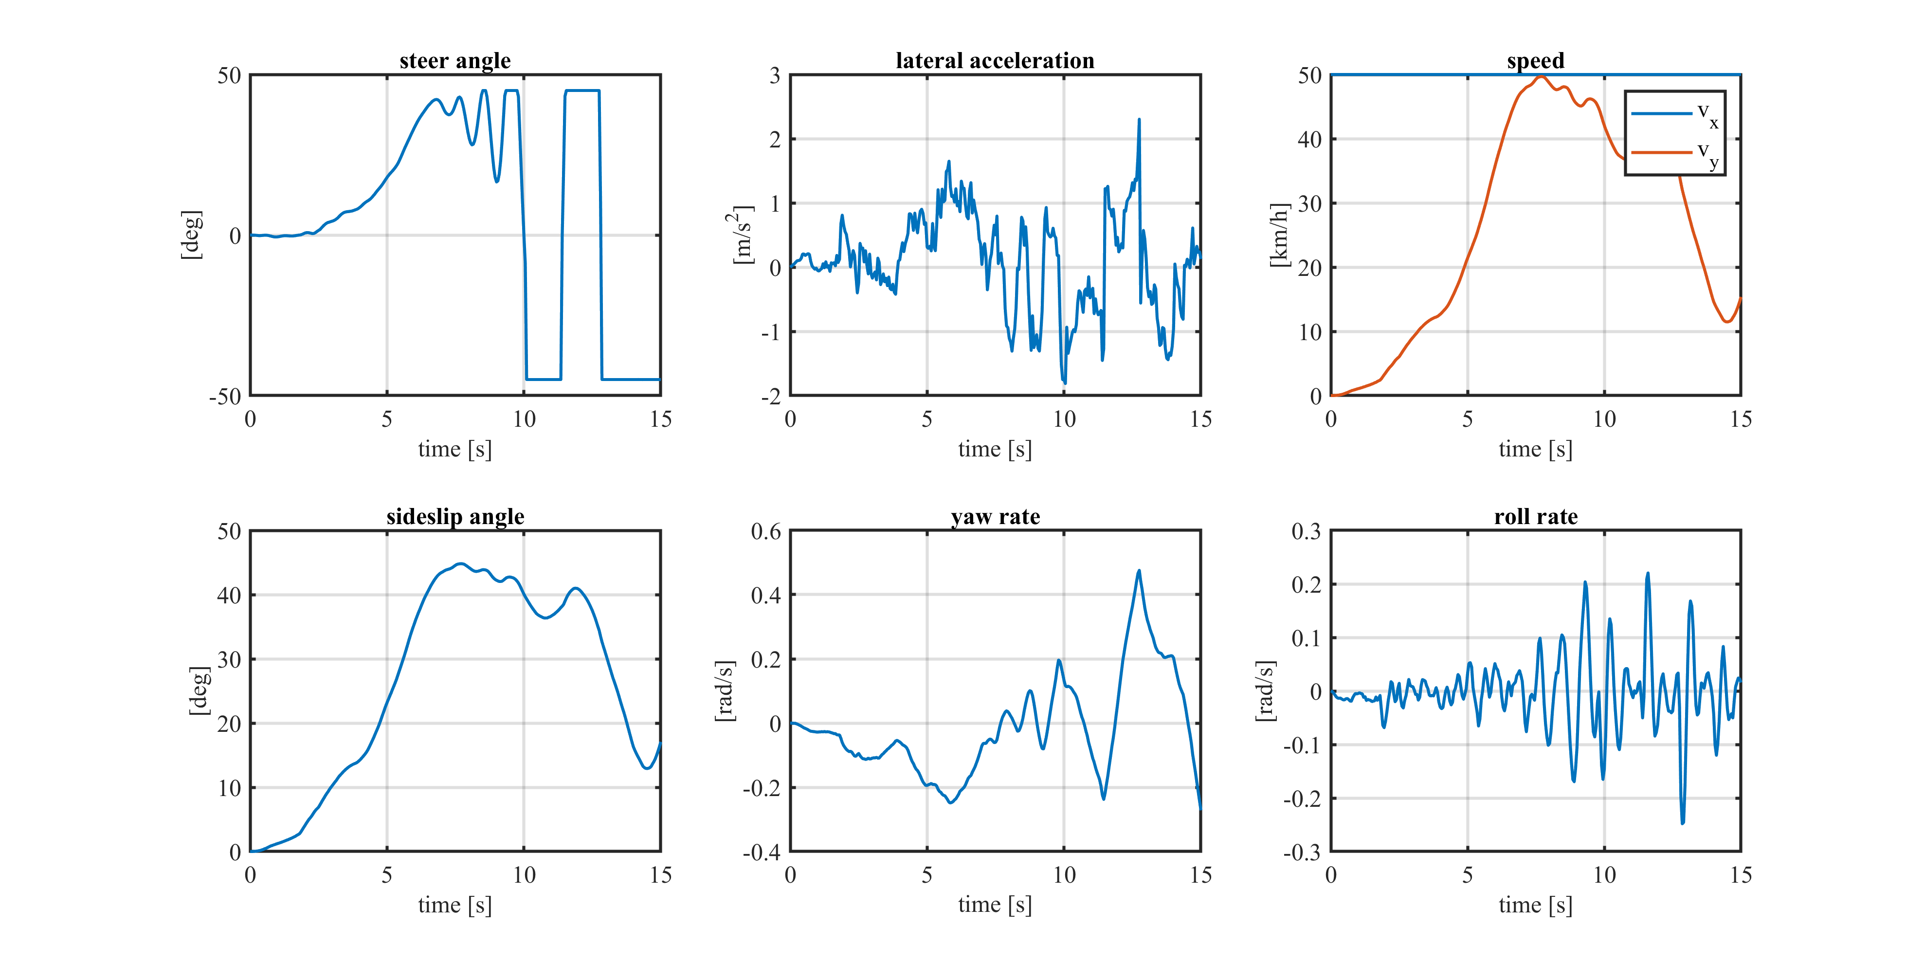As for the *Lambda = 0.5, Snow* case, the truck leaves the road and the simulation is stopped at about 15 seconds.

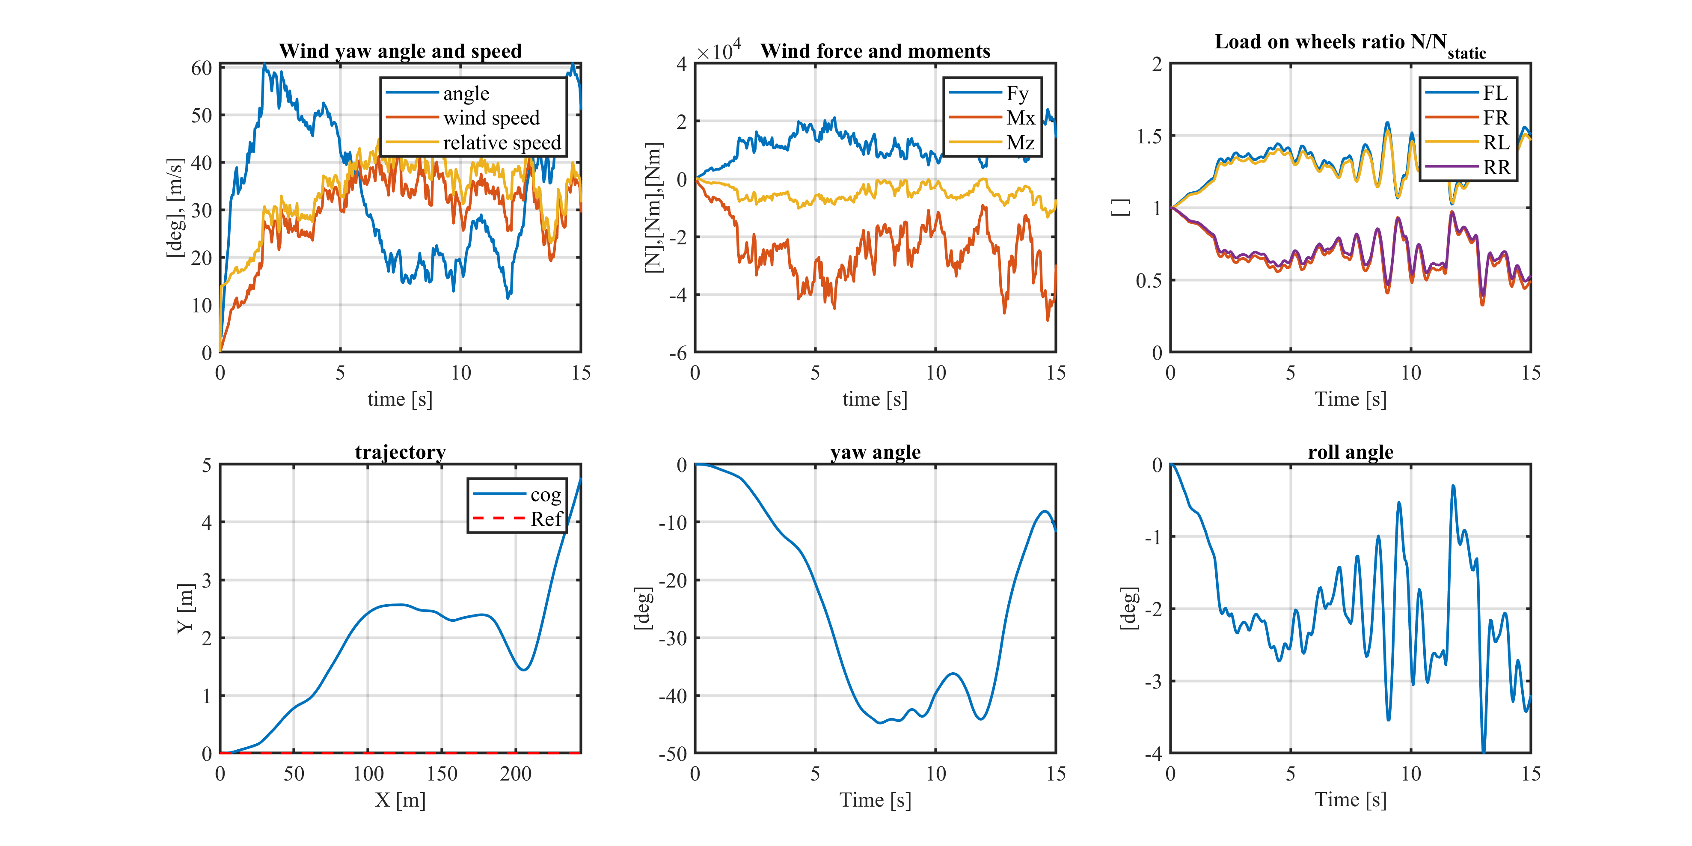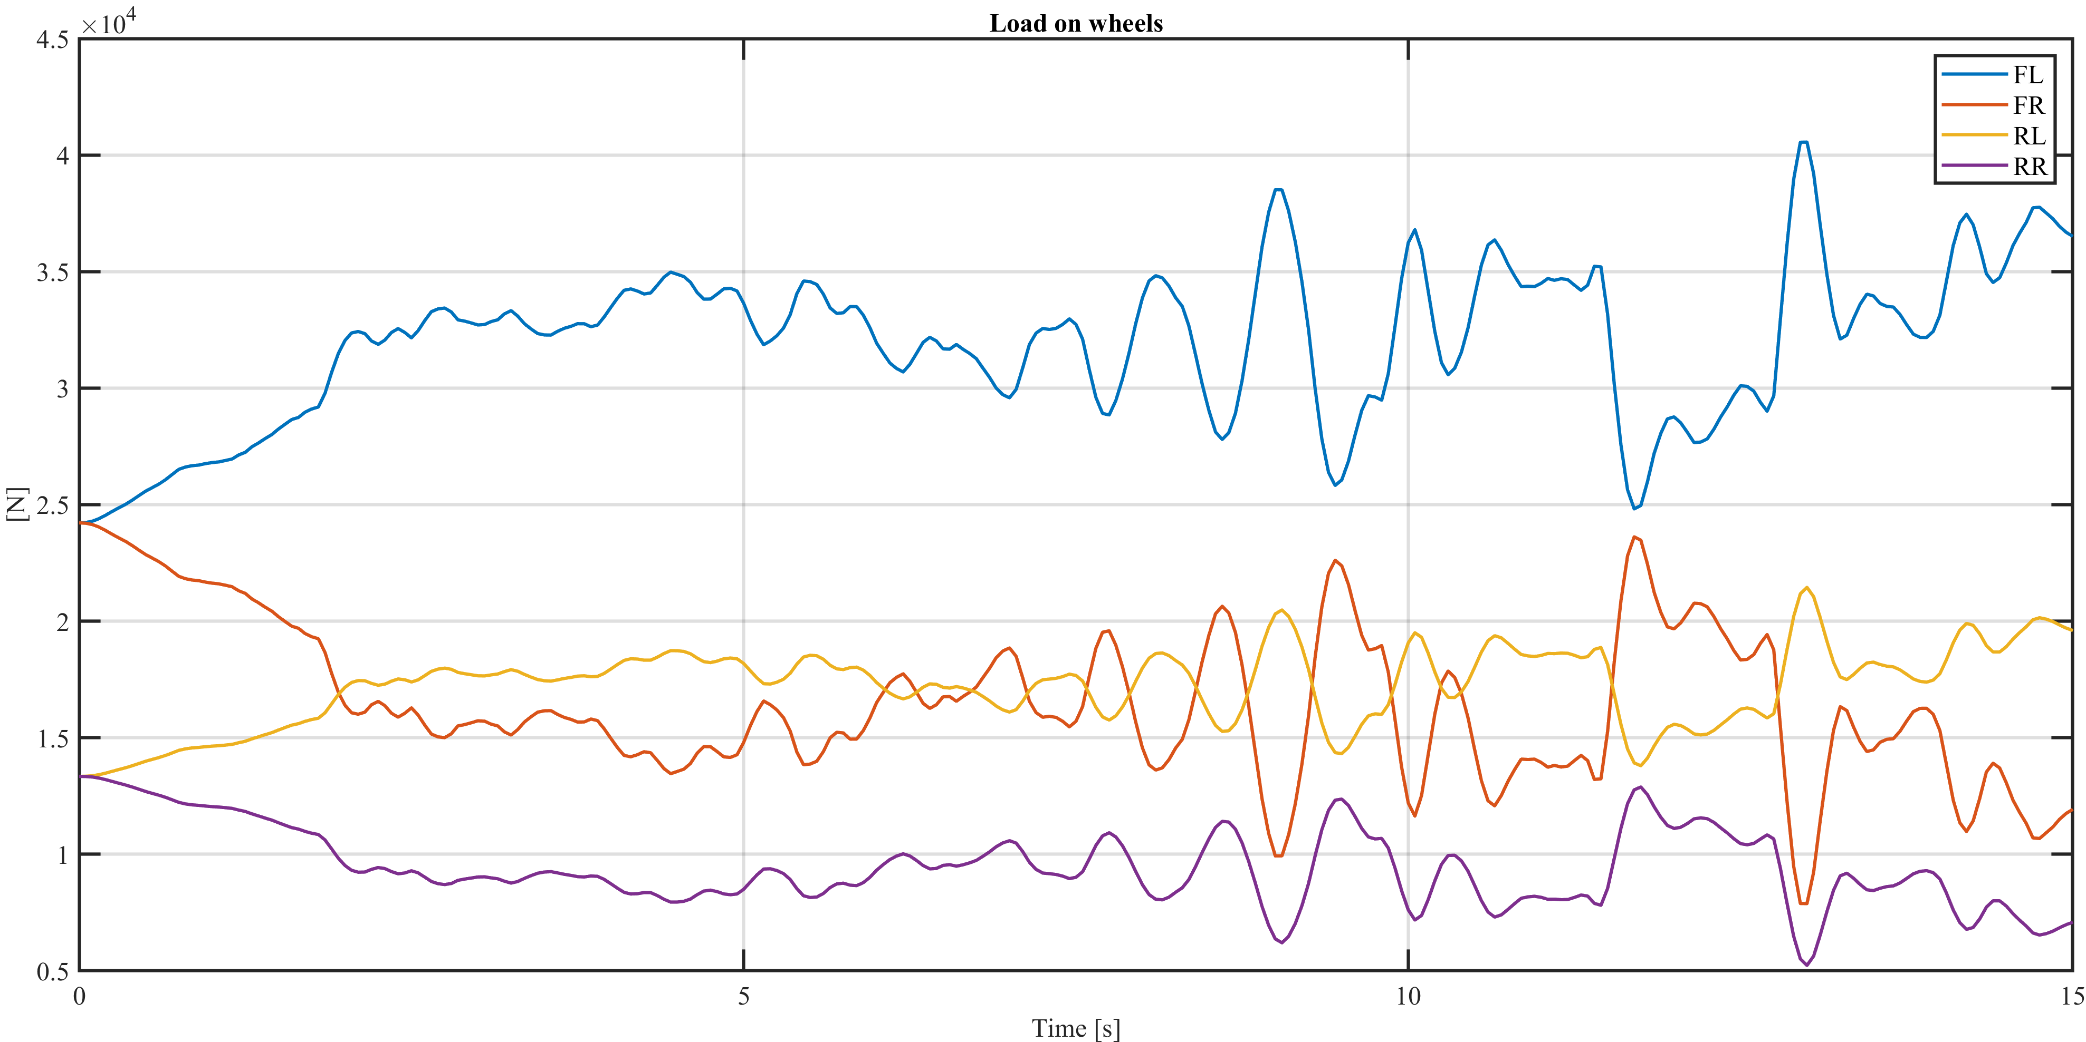

# Entering and exiting from a tunnel

In this simulation the truck enters in a tunnel at 20 seconds and exits at 40 seconds. The gallery is simulated putting the wind velocity equal to 0.4 m/s (not exactly 0 due to numerical reasons). When the truck enters the tunnel, we notice that we get to a static condition after a little transient when the truck still rolls (this can be noticed in the *Load on wheels* and in the *Roll rate* figures). The driver slowly puts the truck back to the desired path. When the truck exits, the action of the wind acts again and we get back to the previous simulations.

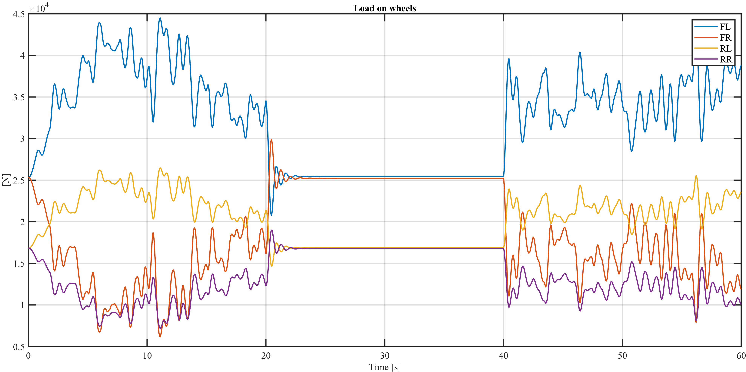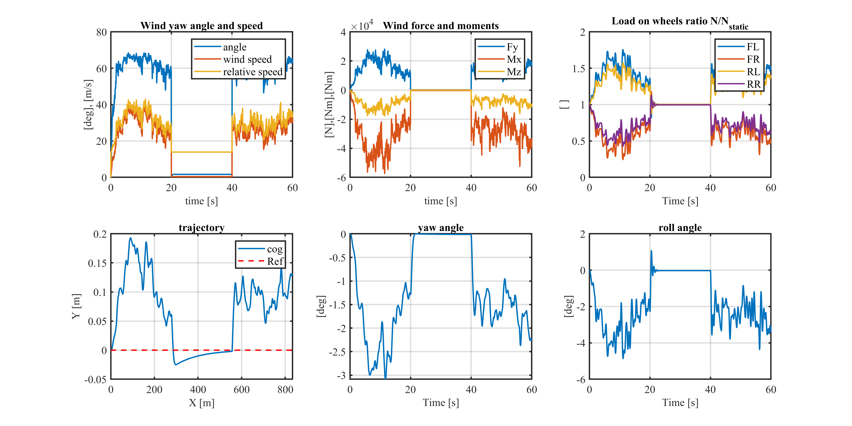

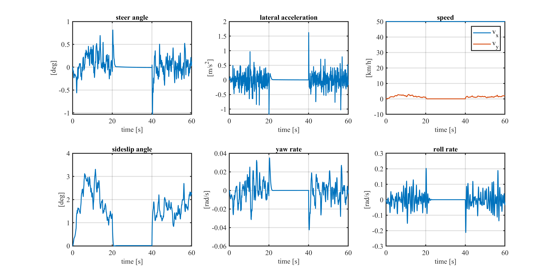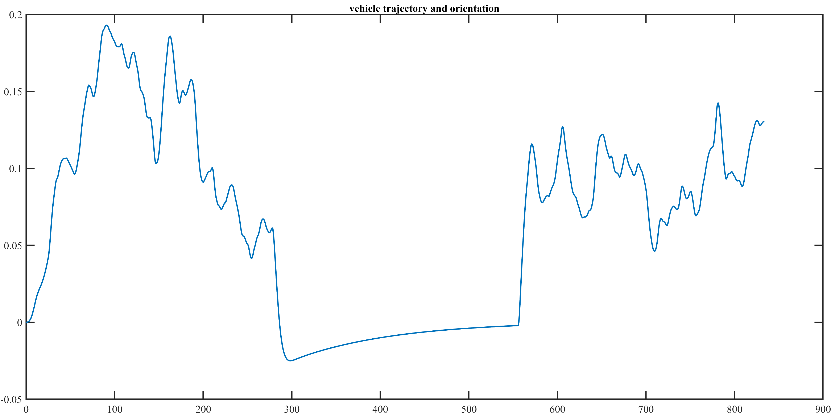

# TAU ROLL ANALYSIS

### DRY CONDITION

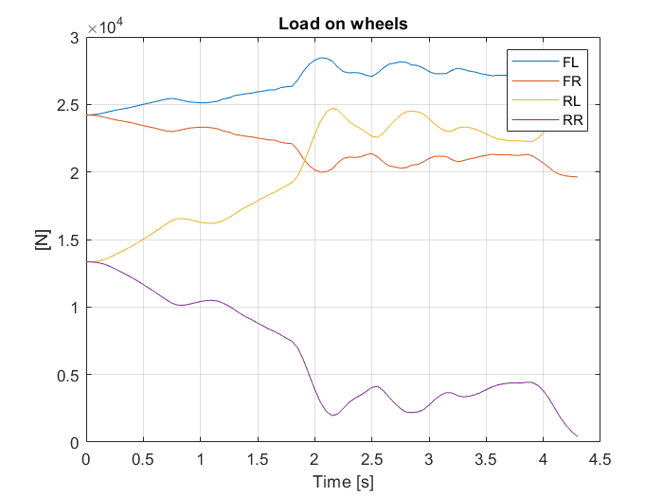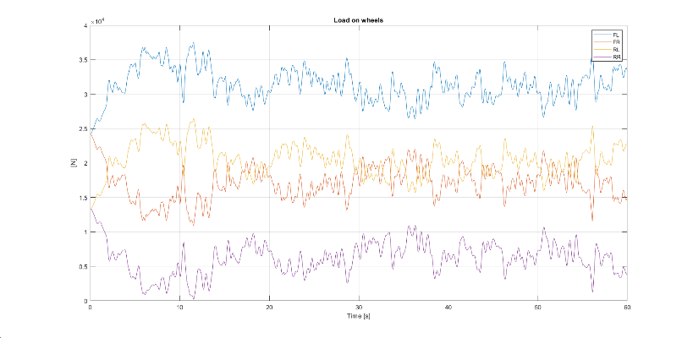

Tau_roll=0.25 Tau_roll=0.5

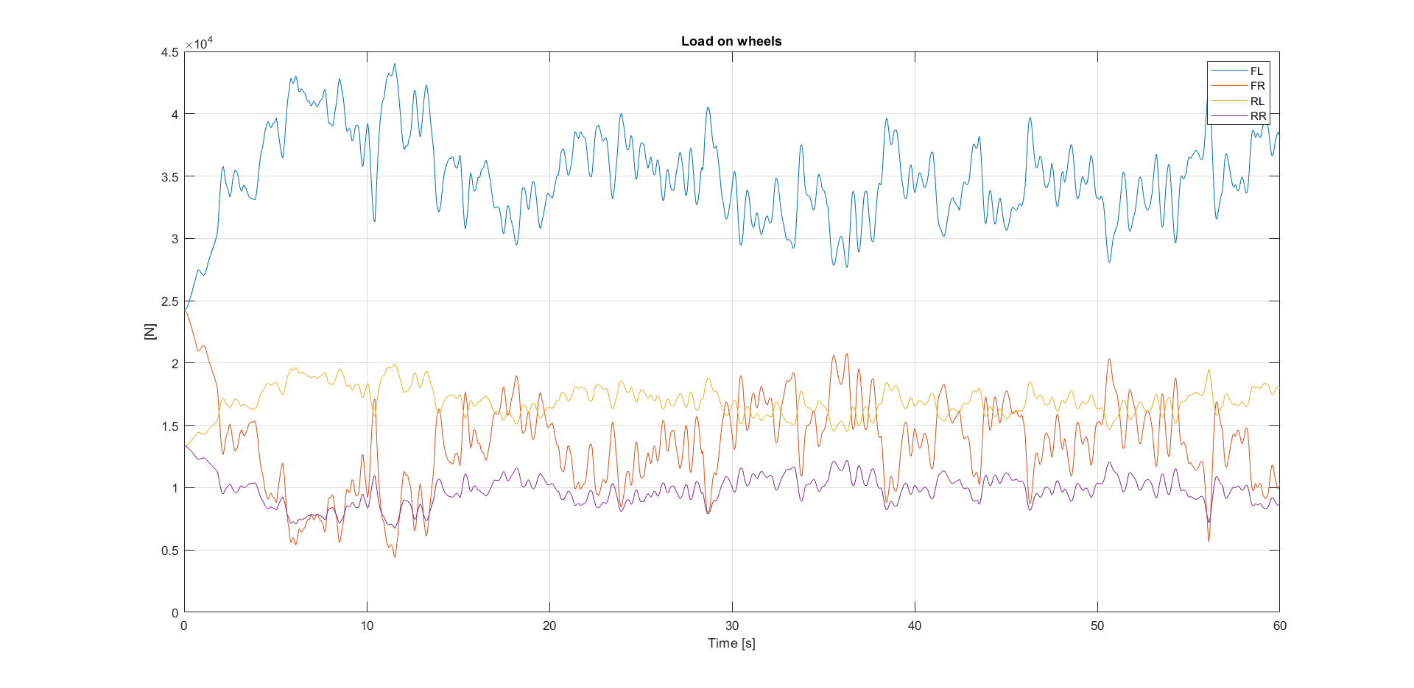

Tau_roll=0.75

No main differences are visible in the yaw, roll, steer and trajectory parameters. The main variation is visible in the distribution of the load over the front and rear axle. With lower tau_roll (hence stiffer rear axle) a large load transfer is observed between the two rear wheels. This reduces significantly the load on the upwind wheel causing rollover.

Increasing tau_roll we get a much lower load transfer on the rear axle and an increasing one on the front. However the front axle has a higher initial load, so the load transfer does not bring to rollover but with tau_roll=0.5 we can see that the load on the RR wheel is still very close to 0 so a critical situation is observed.

In the end tau_roll=0.75 seems to give a fair margin on the rollover given the initial load distribution.

### DRY-WET-SNOW CONDITIONS at TAU_ROLL=0.75

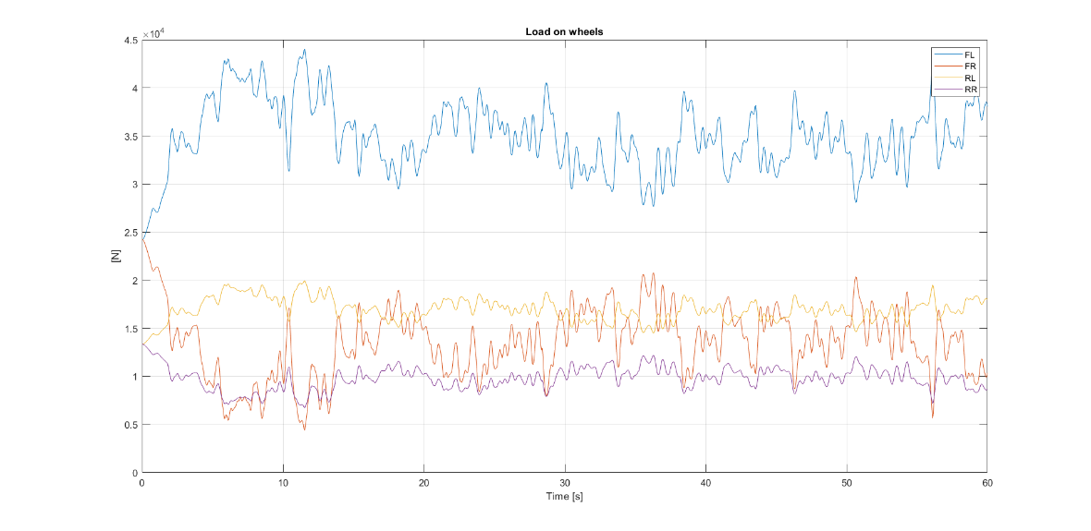

Dry condition

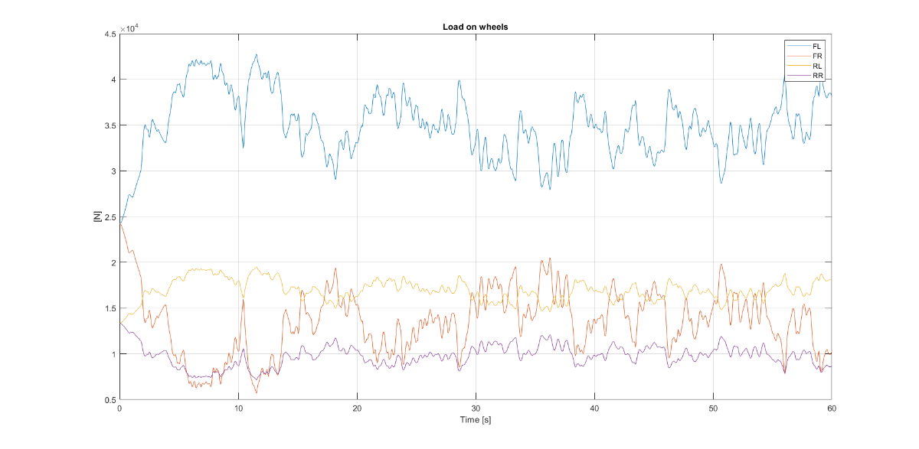

Wet condition

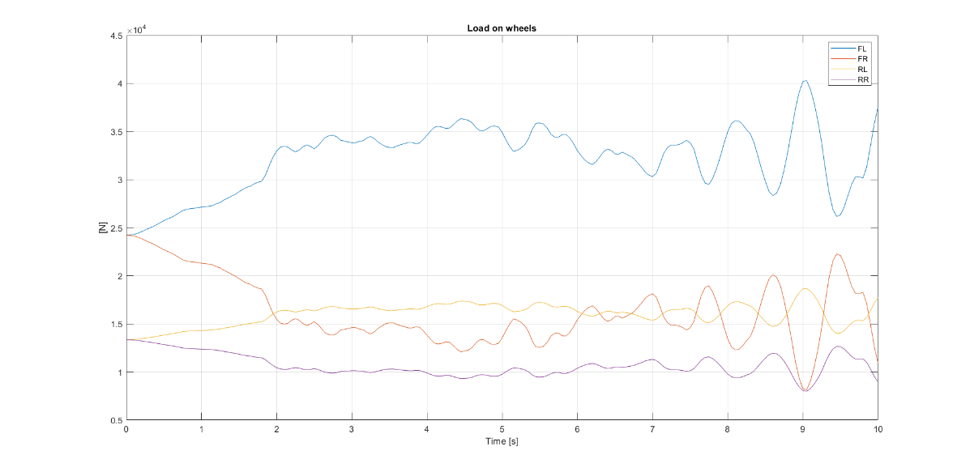

Snow condition

No main differences are observed between the dry and the wet case, however a big difference is present in the snow case. Here the driver input arrives at the steering limit to avoid going out of the trajectory and this produces a strong instability in the response of the car. The simulation is therefore stopped, but of course the vehicle would reach rollover. The issue is due to the fact that the driver increases continuously the steer angle but at some point oversteer occurs (see yaw rate peak) and the driver overreacts. This produces the opposite effect and an unstable behaviour is induced.

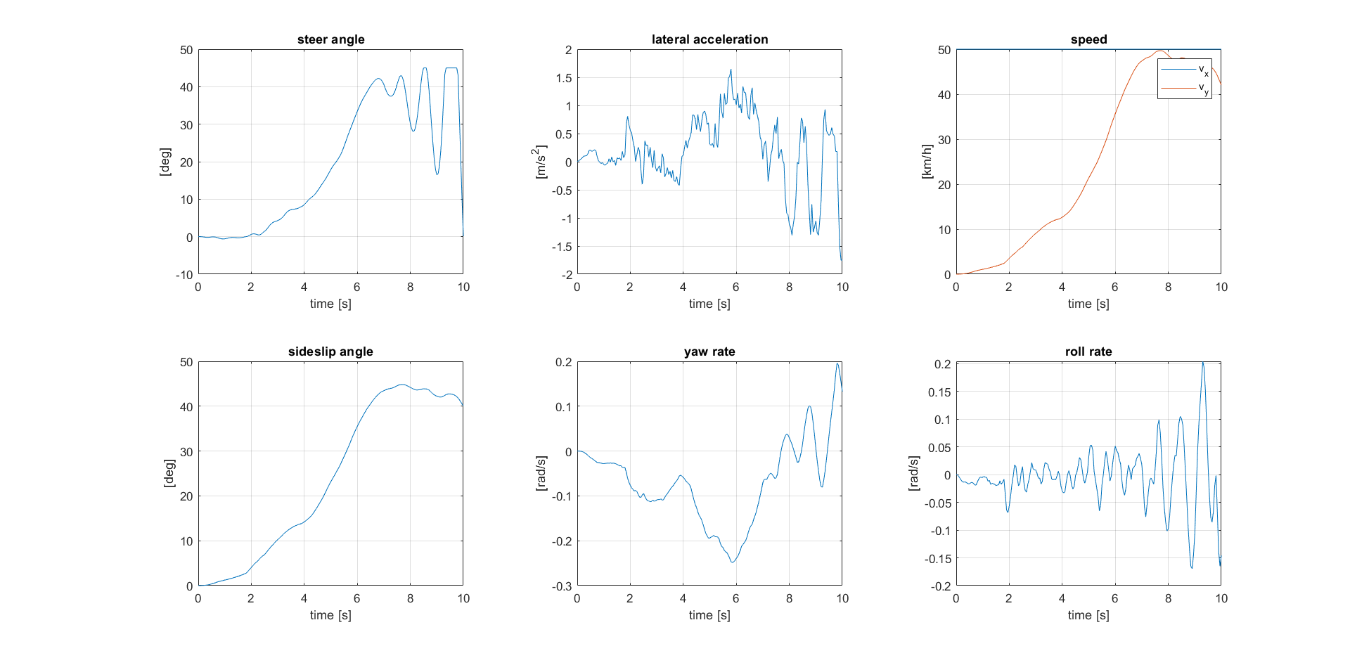

Snow condition

# LANE CHANGE ANALYSIS

### DRY-WET-SNOW CONDITIONS

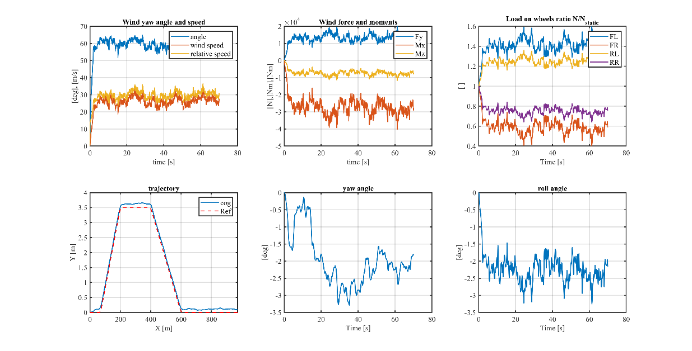

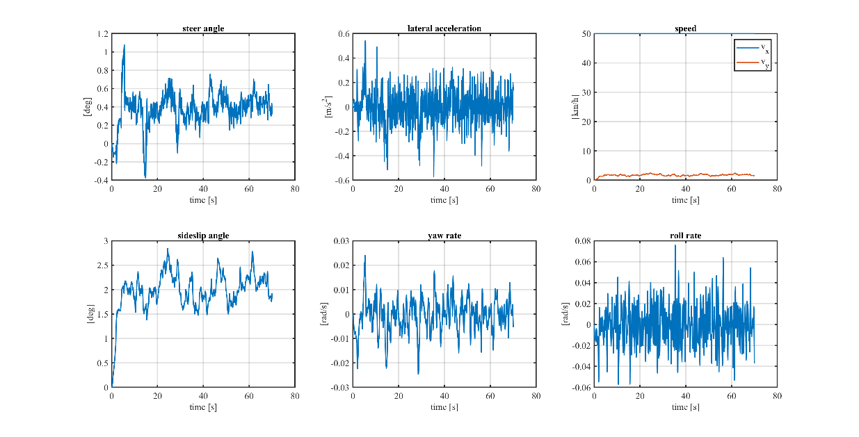

Dry condition

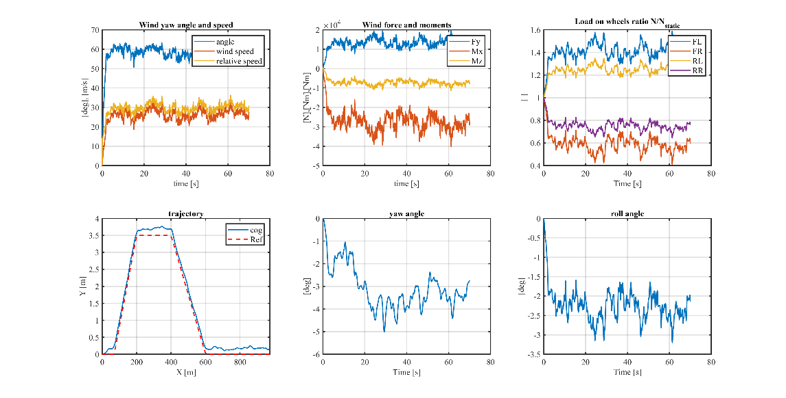

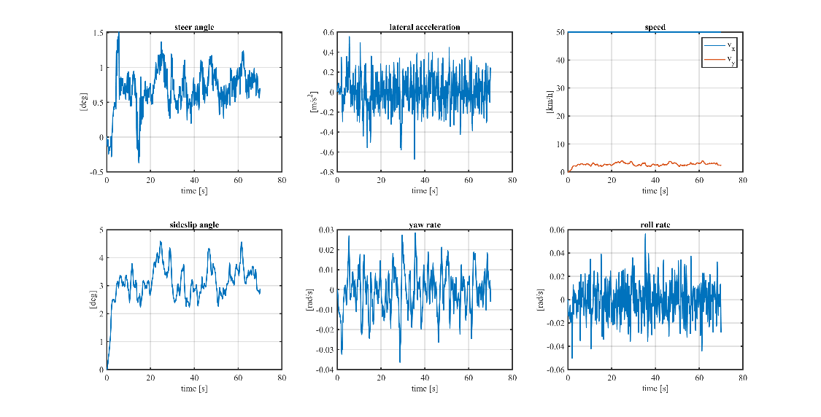

Wet condition

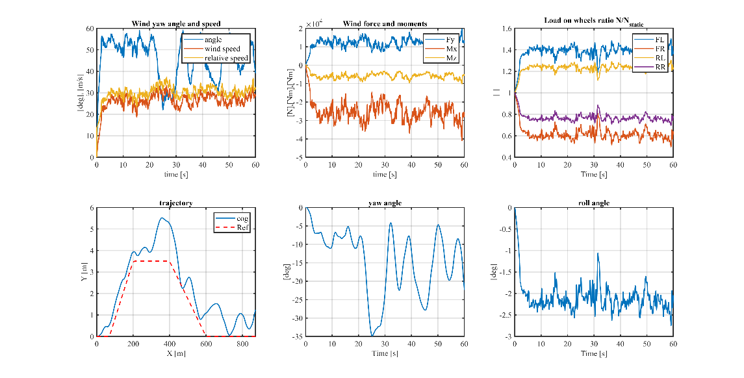

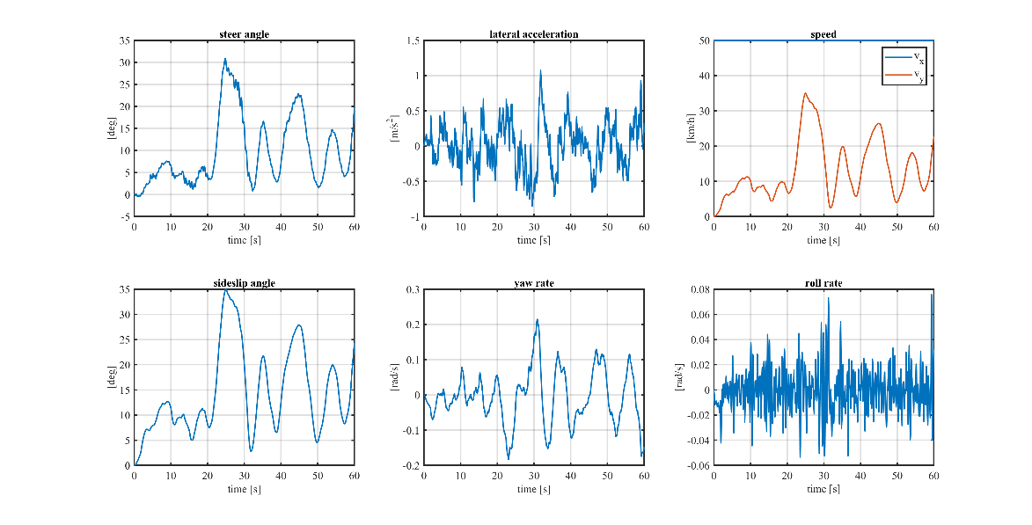

Snow condition

In the wet condition a more unstable trajectory can be observed together with larger yaw angles with respect to the dry case. The reduced grip causes the driver to react with more steer angle to produce enough lateral force to obtain similar lateral accelerations.

In the snow condition the lane change produces a perturbation such that the driver reacts with a strong steering angle and again an unstable behaviour is observed.